Contents

1. XTS ADF Architecture 4

2. Application Start-up 5

2.1 Application Structure 5

2.1.1 Individual Application Structure 5

2.1.2 Common Model Structure 6

2.2 Create and Setup a new ADF Application 7

2.2.1 Create a blank ADF application 7

2.2.2 Attach common ADF library to your new Model & View Controller Project 9

2.2.3 Create Database Connection 11

2.2.4 Setup Project Deployment Profile under View Controller 12

2.2.5 Add Skin in “trinidad-config.xml” 13

2.2.6 Deploy your application from View Controller as JAR 13

2.2.7 Add the application JAR to XTSMaster & xts.shared.lib 14

2.2.8 Revise compilation script to include your application 15

3. ADF Business Components 16

3.1 Prepare Entity Object 16

3.1.1 Creating EO 16

3.1.2 Move the Auto-Generated Association back to the Correct Folder 20

3.1.2 Basic Check on newly Created EO, e.g. PK / Refresh on Insert + Update / etc. 21

3.1.3 Add Validation Rule 23

3.1.3.1 Row Level Validation 23

3.1.2.2 Field Level Validation 25

3.1.4 Locking 27

3.1.3.1 Optimistic Locking (Default) 27

3.1.3.2 Pessimistic Locking (Custom Locking) 28

3.2 Prepare View Object 29

3.2.1 Create View Object 29

3.2.2 Disable Groovy File Generation 34

3.3 Prepare Application Module 35

3.3.1 Create Application Module 35

3.3.2 Update Application Module Setting 37

3.4 Update the Bases Classes 41

3.5 Test the Business Component through BC Tester 43

3.6 Prepare View Object (Continue from Section 3.2) 44

3.6.1 Add LOV into View Object 44

3.6.2 Add Description Attribute 46

3.6.2.1 Add Description Attribute which is based on SQL column in VO Attribute Page 46

3.6.2.2 Add Description Attribute which is based on other EO (Association) 49

3.6.2.3 Add Description Attribute which is based on PL/SQL Validator 51

3.6.2.4 Which approach should be used to show the description? 52

3.6.3 Add View Criteria into View Object 54

3.6.3.1 Setup Basic View Criteria and Advanced View Criteria 54

3.6.3.2 Add CHECK_DIV / CHECK_DPT Checking 57

3.6.3.3 Special setting for WHERE clause using “PRMS_RUNNUM IN (SELECT xxx) 59

3.6.3.4 Add Basic View Criteria into AM Master View Object as default 62

3.6.4 Generate View Object Class for View Object 63

3.6.5 Create View Object for Insert Action 64

3.6.6 Create View Object for Copy Action (To be discussed with Aleksej) 67

3.7 Create View Link 69

4. ADF View Controller 72

4.1 Task Flow Setup 72

4.1.1 Create Task Flow 72

4.1.2 Setup Search Bean and Edit Bean for Task Flow 75

4.1.2.1 Create (1) Search Bean and (2) Edit Bean 75

4.1.2.2 Add Search Bean and Edit Bean into Task Flow 77

4.2 Create Page Fragments for Search Page 79

4.2.1 Create Blank Page Fragment for the page 79

4.2.2 Apply Generic Template and Reusable Toolbar to the page 80

4.2.3 Add table into the Search Page as af:Table 81

4.2.4 Add View Criteria into Page as af:Query 83

4.2.6 Add View Criteria into Page as af:Query 85

4.2.7 Other Basic Setup 86

4.3 Create Page Fragments for Edit Page 87

4.3.1 Create Blank Page Fragment for the page 87

4.3.2 Apply Generic Template and Reusable Toolbar to the page 87

4.3.3 Add table into the Search Page as af:Table 87

4.3.4 Other Basic Setup 88

4.4 Create Page Fragments for Test Page 89

4.5 Set Message Bundle correct location 92

4.6 Pass Division Code from Main Menu to your Task Flow 93

4.7 Create Page Fragments for Search Page (Continue from Section 4.2) 96

4.7.1 Change LOV on search screen filter as Input Text of LOV 96

4.8 Create Page Fragments for Edit Page (Continue from Section 4.3) 97

4.8.1 Create method 97

4.8.1.1 Setup Create Method under VO Implementation 97

4.8.2 Set Enable / Disable of the field 99

4.8.2.1 Enable / Disable Version 2 (Disable Logic Bean) 99

4.8.3 Add Button for detail table 100

4.9 Update ADF Security in XTS Master to include the new task flow 101

4.10 Other General Setting on UI Page 102

4.10.1 Refresh EditToolBar / DetailToolBar after save 102

4.11 Break a big JSF page into multiple fragment 103

4.11.1 For contents which are always shown (XA-440) 103

4.11.2 For contents which are programmatically shown 104

4.11.3 To synchronize the record change from master block and detail block (through association) 109

4.11.4 To synchronize the record change from master block and detail block (through execute query) 109

4.12 Responsive UI 110

4.13 Call FORM from ADF 111

4.14 Call ADF from ADF 111

4.15 Call Attachment 112

5. Special Use Case (Logic) 113

5.1 Check Unique PK when create record 113

5.2 Prevent PK locking issue 114

5.3 Add Row Sequence in DB to prevent ADF editable primary key issue in af:table 114

5.4 How to handle LONG data type field? 115

5.5 Call PLSQL with ROWTYPE as output parameter 115

5.6 How to not run the query when page load (due to AM initialize the VO) 115

5.7 OR Runnum correct solution 115

6.1 Format Mask 116

6.1.1 Set Field as UPPERCASE 116

6.1.2 Format Mask for Number Field 116

6.1.3 Conceal Data 117

6.2 Add Short Cut Key 117

6.3 LOV Code and Value Setup 117

6.4 Add Detail / Delete Detail Button 118

6.5 af:table Column Width Setting 118

6.6 Revise Instance Name in pageDefinition (12.2 bug?) 119

6.7 How to create checkbox in UI ? 120

6.8 Trigger logic after LOV 120

6.9 How to set partial trigger? 120

6.10 When should you use pageFlowScope bean vs backingBeanScope bean? 120

6.11 In Oracle Form, we always check if PRE-TEXT-ITEM <> POST-TEXT-ITEM 120

6.12 Programatically assign value into VO 120

6.13 LOV Switcher 121

6.14 Programmatically called button 124

6.15 Reset Pop-Up Dialog 124

6.16 Advance Search Standard 124

6.17 Suppress LOV to pop-up 124

6.18 LOV inside LOV searching criteria 124

6.19 Initialize variable when Form is loaded 125

6.20 Conditionally refresh the field based on the result of ADF BC logic 125

6.21 Set Label and Width Proportion 125

6.22 Programmatically set Advanced Search Label when Division Code change 125

6.23 Suppress LOV Prompt Out and Show Error Message 125

6.24 Checkbox: Combine 2 Request into 1 and Change Checkbox to VO Attribute only 125

7. Performance Tuning 126

8. Database Change Sync to ADF 127

9. Server Log 128

# 1. XTS ADF Architecture

* XTSCommonModel
* XTSCommonUtils
* XTSCommonViewController
* XTSMaster
* XTSBankMst
* XTSProfile
* XTSShpInv

Please be noted that some of the screenshot is taken in 12.1.3

As a result, the folder path may be under C:\JDeveloer\XTS.

For 12.2.1.1, it should be under C:\JDeveloper\12211\XTS

# 2. Application Start-up

## 2.1 Application Structure

### 2.1.1 Individual Application Structure

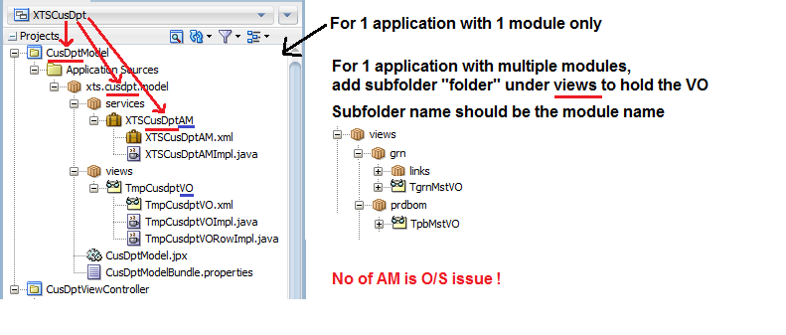

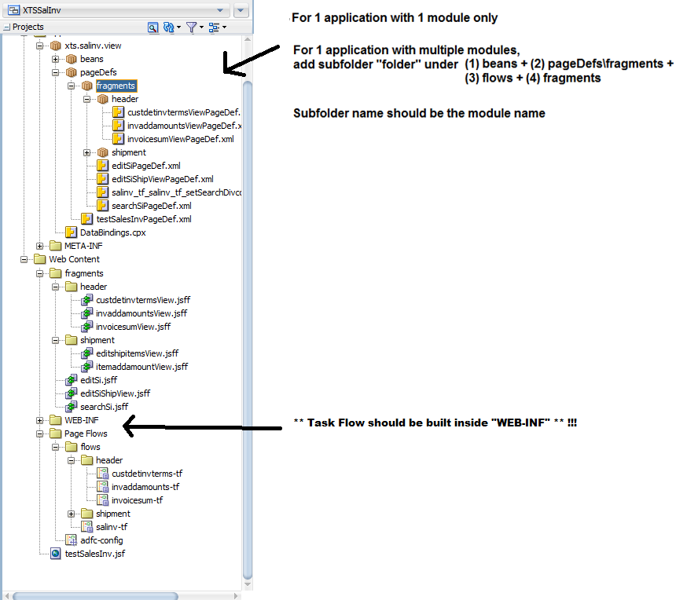

1. ** Be careful on the File Path and the naming. Please follow the standard defined in 2.1 Structure for an ADF Application **

### 2.1.2 Common Model Structure

* For new table, please add under “entities” tree as below
* For new association, please add under “assocs” tree as below

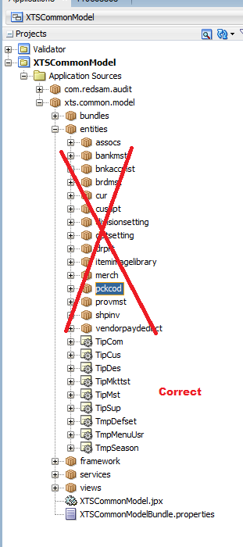

## 2.2 Create and Setup a new ADF Application

### 2.2.1 Create a blank ADF application

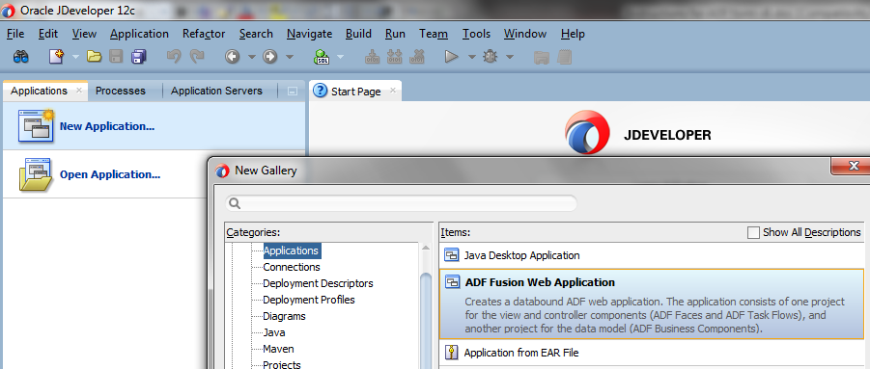

* For the application name, you may refer to the master table name / module name.
* Please make sure the path is now at C:\JDeveloper\12211\XTS instead of C:\JDeveloper\XTS
  + For example, Customer Department Maintenance / TMP_CUSDPT -> XTSCusDpt

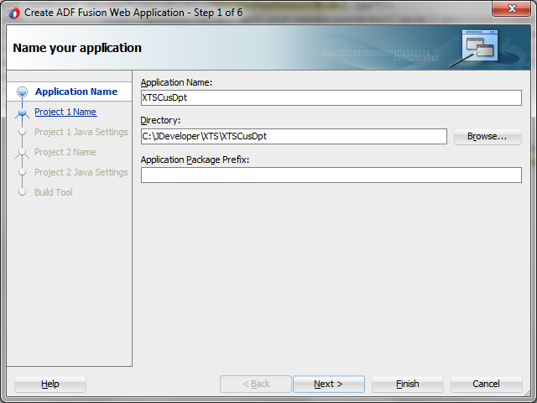

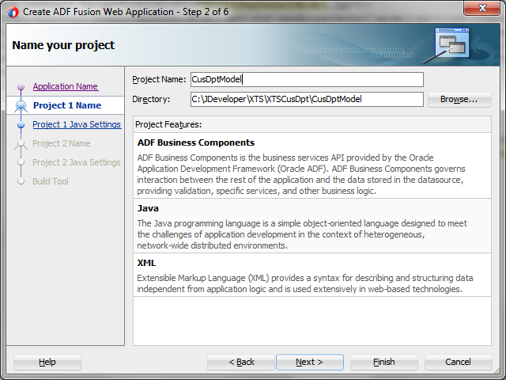

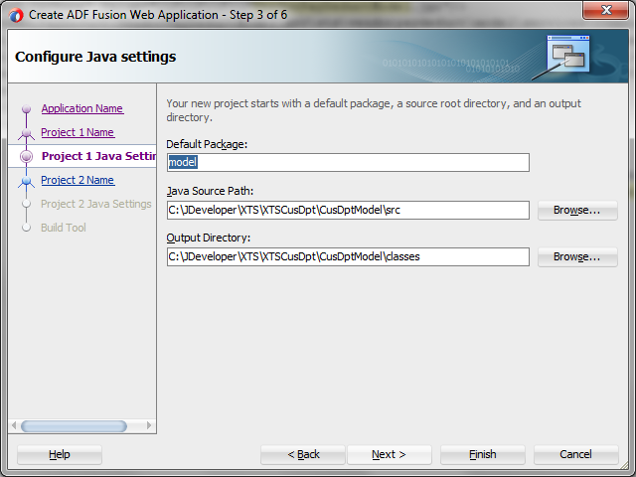

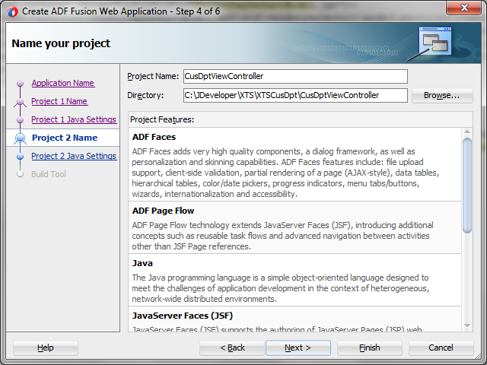

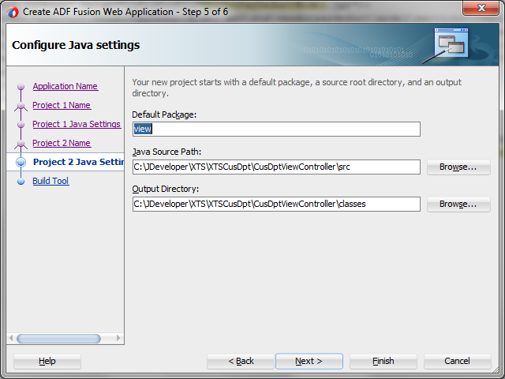

* Final Result

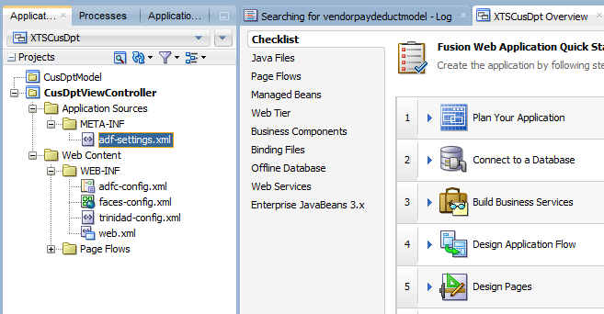

### 2.2.2 Attach common ADF library to your new Model & View Controller Project

1. **Attach “ADF Library” to “Model” project**

* Right Click Model -> Project Properties
* Select Libraries and ClassPath -> Add Library button

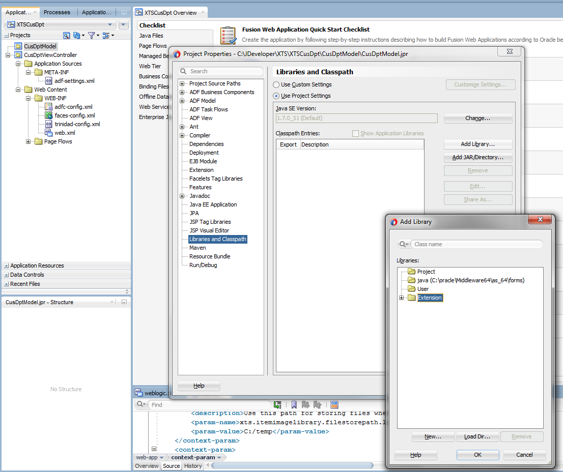

* Press “New” to add library and input library name as below. Press “Add Entry” to add jar into the class path
* and select “Deployed by Default”

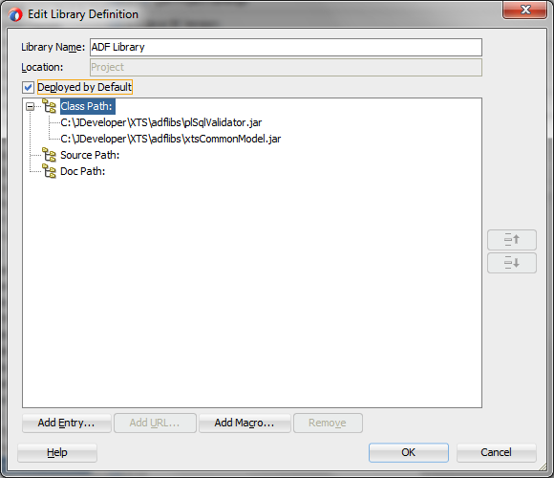

1. **Attach “ADF Library” to “View Controller” project**

* Right Click View Controller -> Project Properties
* Follow previous step to create a new “ADF Library” and add the following to the class path and select “Deployed by Default”

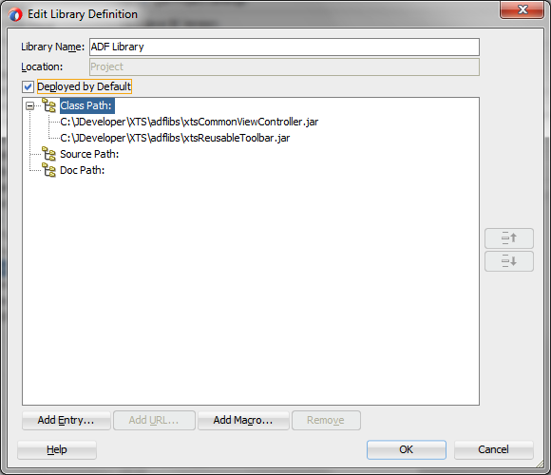

### 2.2.3 Create Database Connection

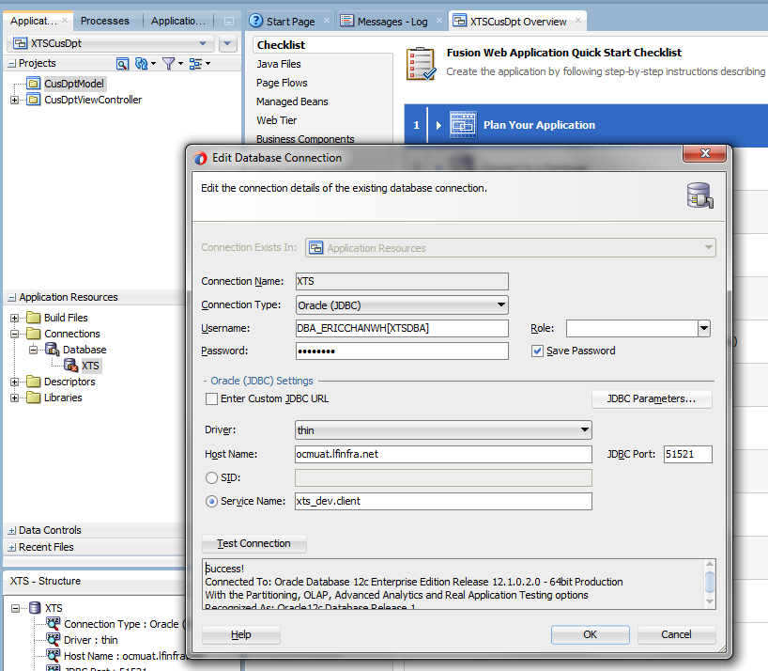

We need to create a database account for compile (Discuss with Steven) !!

### 2.2.4 Setup Project Deployment Profile under View Controller

* Right Click View Controller -> Project Property -> Deployment
* Remove existing Profiles

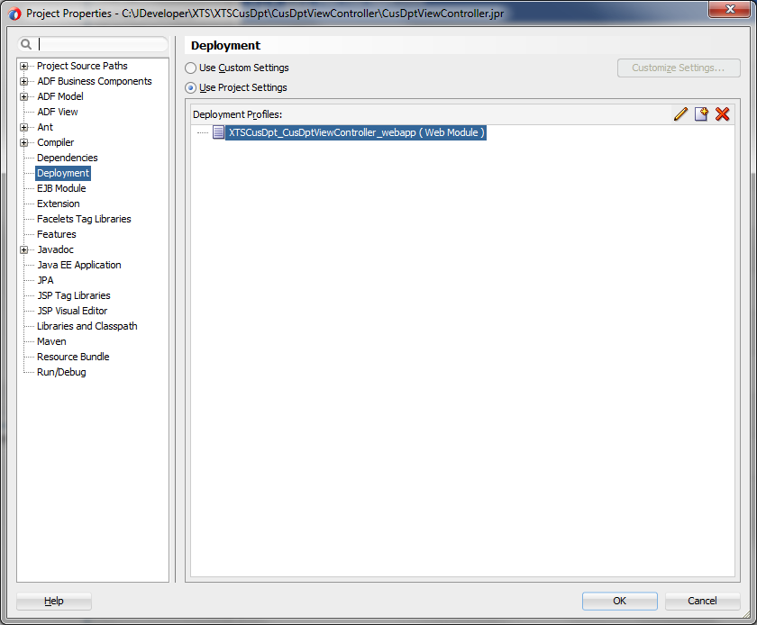

* Create a new Profiles in lower case and then press OK

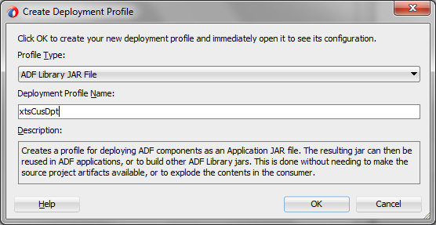

* For Library Dependencies / Connection / ADF Validation tab keep default
* JAR options changes as below

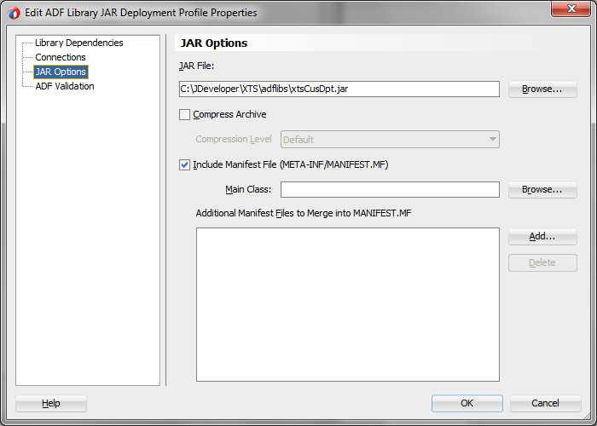

### 2.2.5 Add Skin in “trinidad-config.xml”

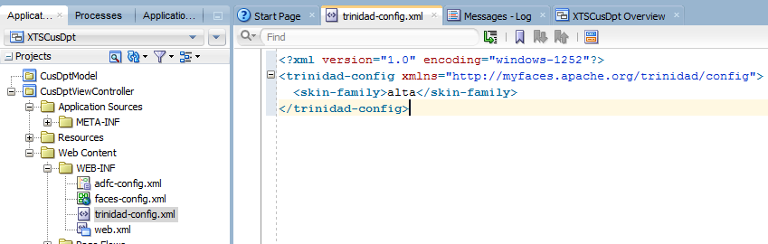

### 2.2.6 Deploy your application from View Controller as JAR

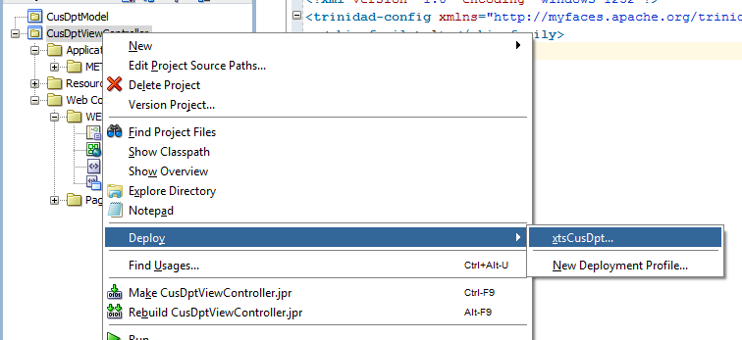

* Accept the path as below

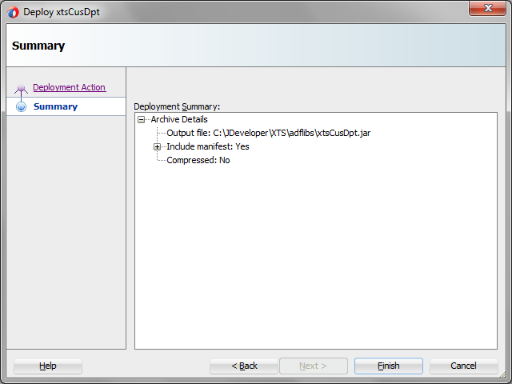

### 2.2.7 Add the application JAR to XTSMaster & xts.shared.lib

* Add back the JAR to XTSSharedLib + XTSMaster View Controller
* Right Click XTSSharedLibs (For Server Run) -> Project Properties, add JAR as below

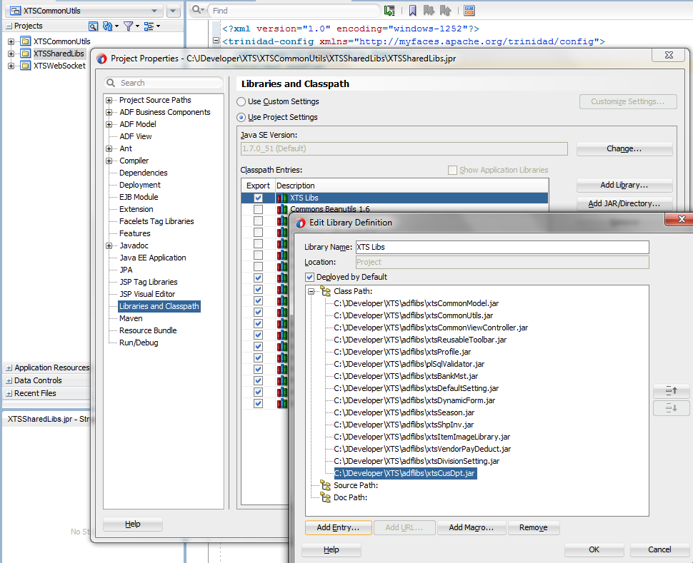

* Right Click XTS Master View Controller (For Local Run) -> Project Properties, add JAR as below

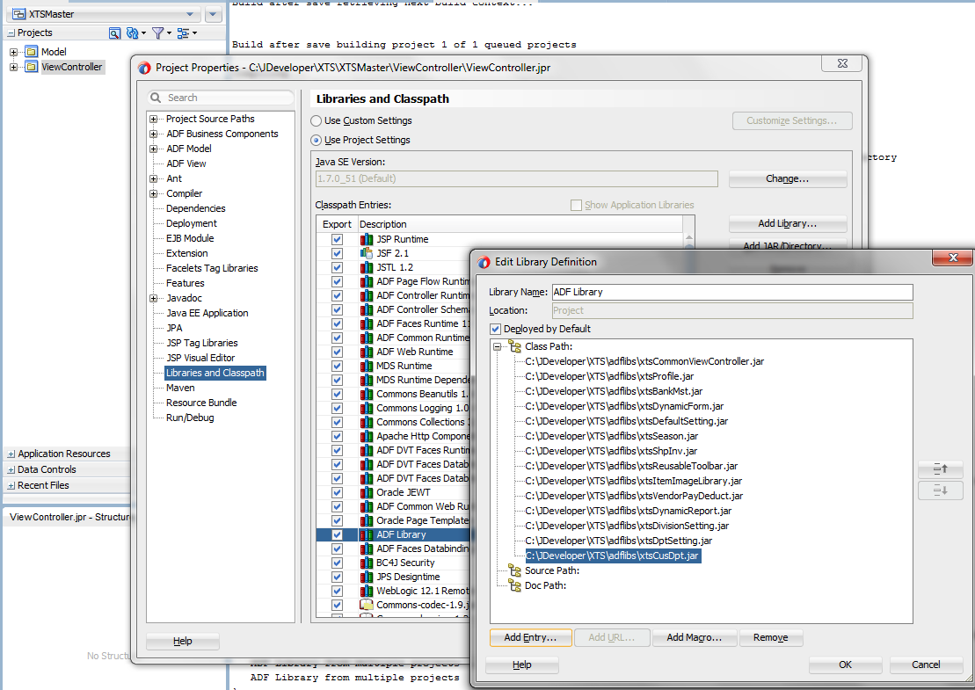

### 2.2.8 Revise compilation script to include your application

* Revise C:\JDeveloper\XTS\build\ojdeploy-build.xml to include your application for compilation
* Search xtsitemimagelibrary as an example

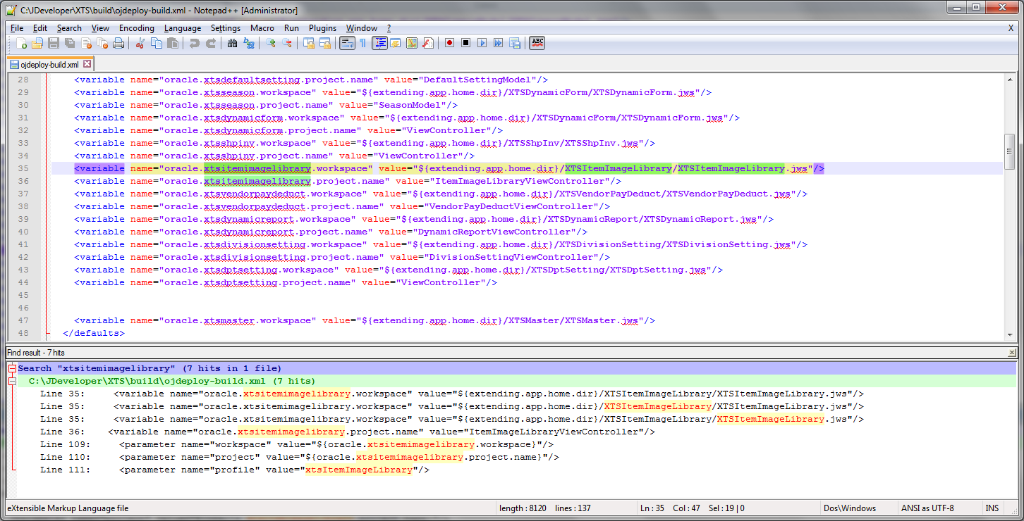

* Run run_ojdeploy.bat and make sure your new application can be compiled, e.g. xtsCusDpt

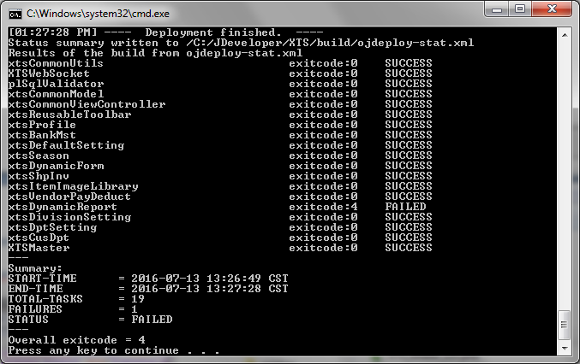

# 3. ADF Business Components

## 3.1 Prepare Entity Object

### 3.1.1 Creating EO

* Before create EO, make sure the table definition in development site is the same as production site.
  + Let us know if they are difference!!
  + Please extract script for all table in DEV and COPY and use ExamDiff to compare it

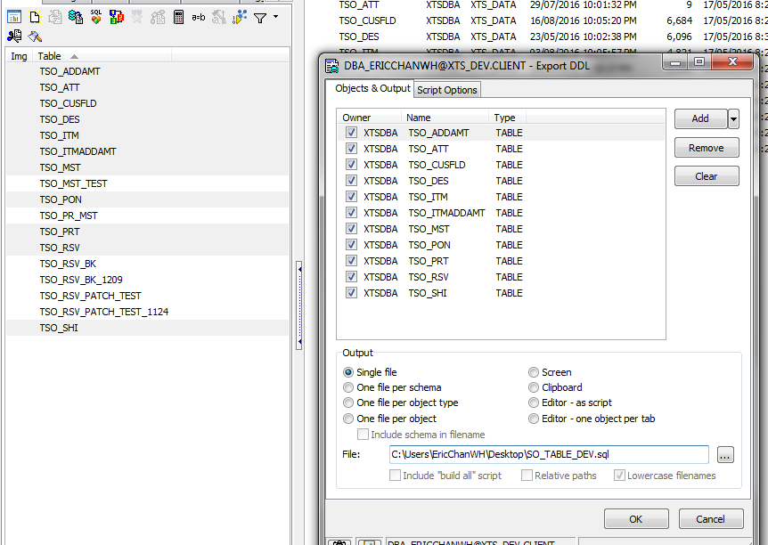

* On xts.common.model.entities, right click create Entity Object, and then input information as the screen below, and then accept “Next” in the coming tab until “Finish”.

** Be careful on the File Path and the naming. Please follow the standard defined in 2.1 Structure for an ADF Application **

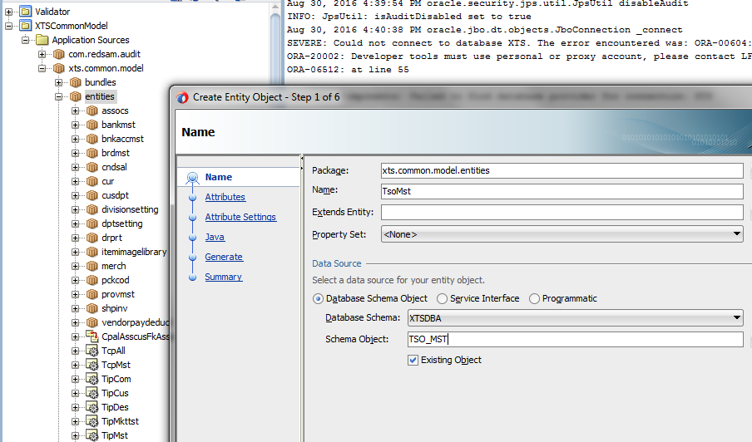

* On Java Tab, Generate Entity Object Class and press “Classes Extend” and update Row to

xts.common.model.framework.GenericPLSQLEntityImpl

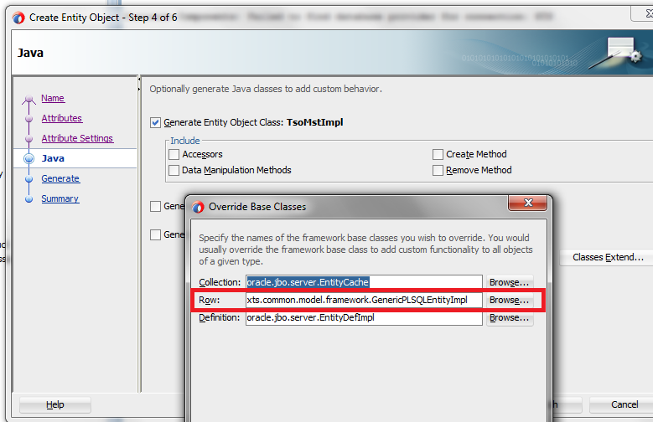

Here’s the final output.

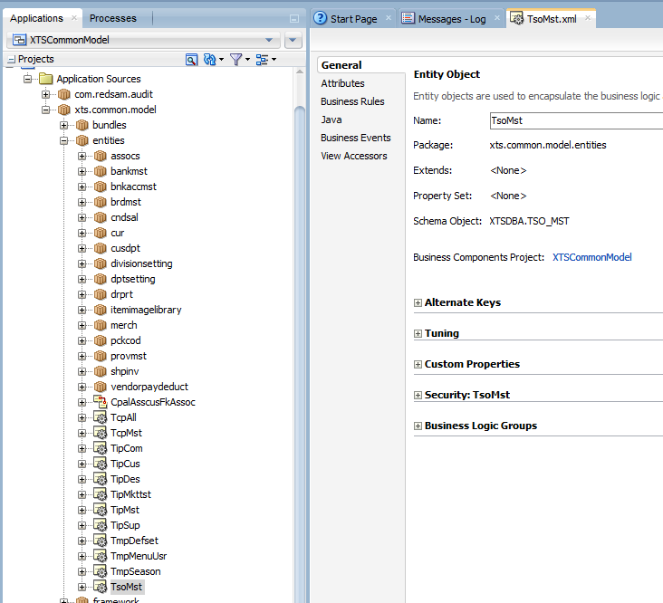

### 3.1.2 Move the Auto-Generated Association back to the Correct Folder

* By default, JDeveloper will generate association based on the FK as association and it will generate at the same level as EO
* Please refactor the association to association folder instead (xts.common.model.entities.assocs)
* JDeveloper will not able to update the association in EO.
  + Revise every related EO by searching “Assoication” and revise the path as below

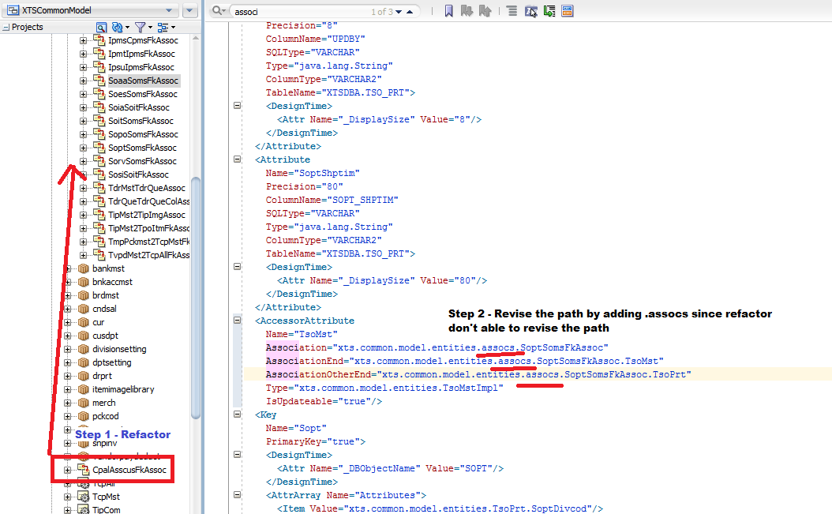

### 3.1.2 Basic Check on newly Created EO, e.g. PK / Refresh on Insert + Update / etc.

* Check Primary Key, Mandatory
* On Crtby and Crtdat check “Refresh on Insert”
* On Updby and Upddat check “Refresh on Insert” and “Refresh on Update”
* *** If there is anything update in trigger, you should also select “Refresh on Insert” and “Refresh on Update” ***
* *** If there is anything update in PL/SQL within 2 request, you are not expected to use Optimistic Lock ***

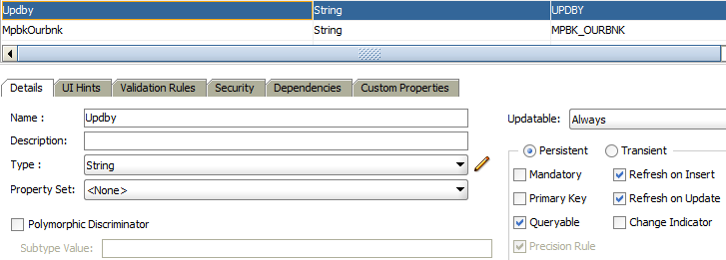

* Create New Column CrtbyUserName and UpdbyUserName as below
* Please use DP_UTL.F_USERINFO as a standard

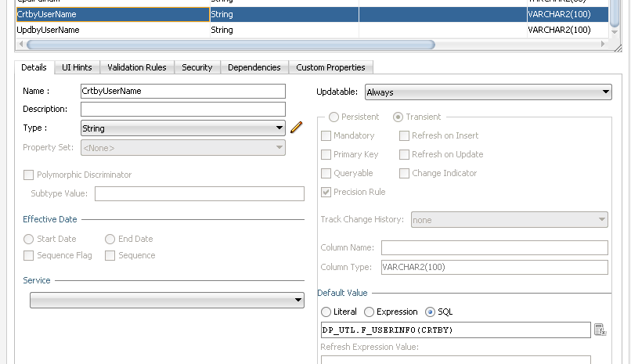

* Update Label from UI Hints Tab

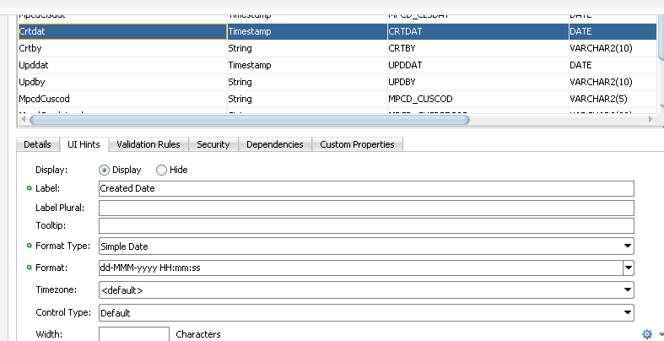

* Currently there are only 2 kind of data format
  + dd-MMM-yyyy (Deactivated Date)
  + dd-MMM-yyyy HH:mm:ss (Create Date, etc..)

### 3.1.3 Add Validation Rule

3.1.3.1 Row Level Validation

i) Normal Setup Flow

* Check if a package for your module exists or not. If not, create one.
* Create the following function for Row Level Validation, may follow DP_CUSDPT

PROCEDURE PL_RAISE_ERROR_TO_ADF ...

PROCEDURE PL_RESET_MSG_ARRAY ...

FUNCTION FL_GET_NO_OF_MSG_IN_MSG_ARRAY ...

PROCEDURE PL_ADD_MSG_TO_MSG_ARRAY ...

FUNCTION FL_VALIDATE_TMP_CUSDPT ...

PROCEDURE PL_VALIDATE_TMP_CUSDPT_ROWTYPE ...

* From EO Custom Properties, add “Non-Translatable Property” with ROW_TYPE_VALIDATION=true

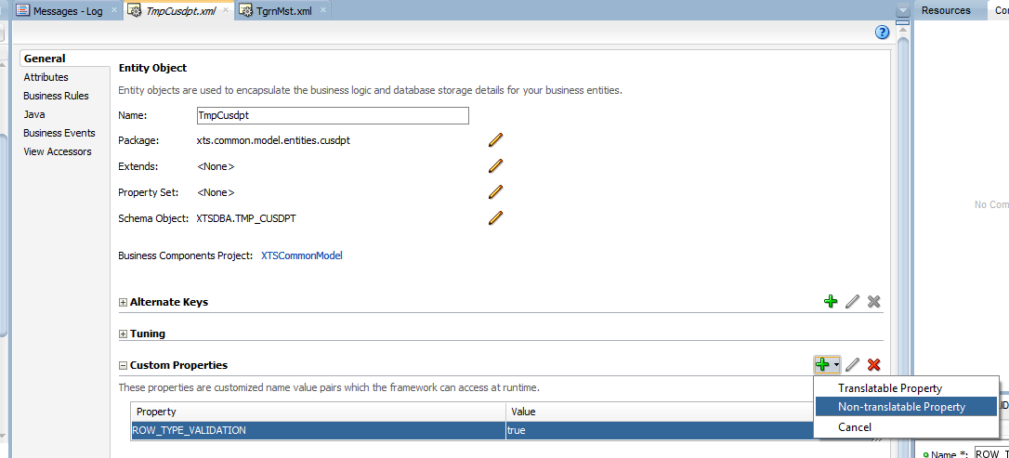

* By default, it will base on the package name to call the package using the following pattern DP_XXX.PL_VALIDATE_YYY_ROWTYPE, e.g.
* DP_CUSDPT.PL_VALIDATE_TMP_CUSDPT_ROWTYPE

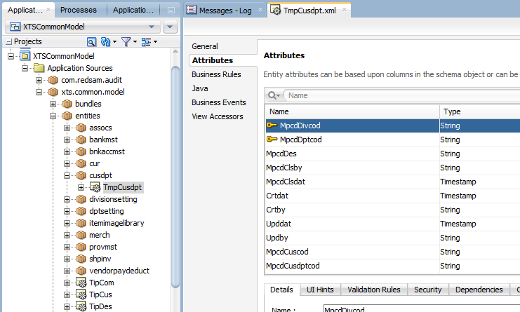

* You need to define new custom property “ROW_TYPE_VALIDATION_FUNCTION_NAME”

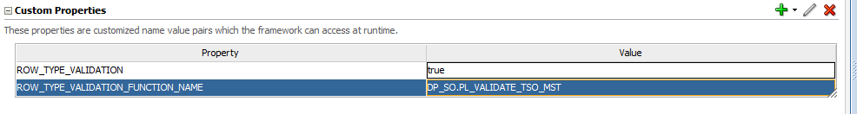

ii) Pass extra parameter for Row Type validation

May also refer to XA-718

@Override

protected void doDML(int operation, TransactionEvent transactionEvent) {

if (operation != DML_DELETE) {

LinkedHashMap<String, Object> extraParams = new LinkedHashMap<String, Object>();

Object param1 = this.getDBTransaction().getSession().getUserData().get("IpmsCusdptEnableDisable");

extraParams.put("P_IPMS_CUSDPT_ENABLE", param1);

super.xtsValidate(extraParams);

}

super.xtsDoDML(operation, transactionEvent);

}

Iii) Skip Validation

Set ADF_STANDARD_VALIDATE = ‘true’

You may also refer to XA-588

3.1.2.2 Field Level Validation

* Add Validation Rules under EO Attribute

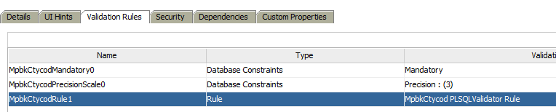

* Set the Type: PLSQLValidator

i. Procedure

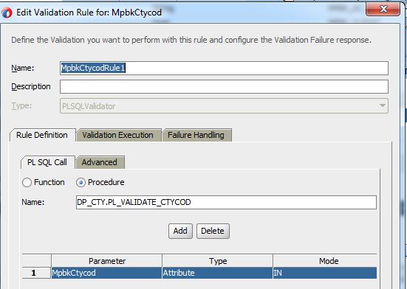

* + - * Use IN and OUT parameters
        + It can be multiple IN / OUT parameter
        + OUT parameters used to fill in the RETURN VALUE
        + (To be further updated by Eric) Create Transient attribute and use this attribute as OUT parameter in PLSQL Validator, in Advanced tab check Post-Query. (example: XTSCommonModel -> TipMst -> IpmsFlycod and IpmsFlycodDes)

*But EO attribute, which filled with PLSQL Validator can't be used in table filter.*

ii. Function

To be further check

### 3.1.4 Locking

3.1.3.1 Optimistic Locking (Default)

* From EO Custom Properties, add “Non-Translatable Property” with USE_STANDARD_LOCKING = true

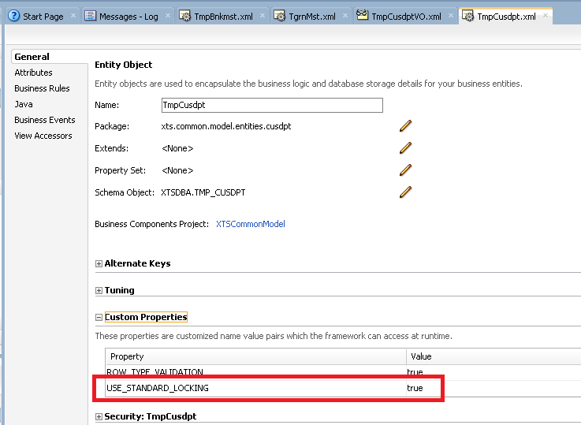

Some important notes for Optimistic Lock

* Please refer to XA-369 (Number save in DB 400.10 / ADF 400.1 Issue)
* Cannot use POST comment in ADF
* Cannot use PL/SQL call to Insert / Update DB record since they may under different connection from next request

3.1.3.2 Pessimistic Locking (Custom Locking)

* By default, it will base on the package name to call the package using the following pattern DP_XXX.PL_LOCK_XXX_ROWTYPE, e.g.
  + DP_GRN.PL_LOCK_GRN_ROWTYPE
* For custom function name, please add custom property “ROW_TYPE_LOCKING_FUNCTION_NAME”.

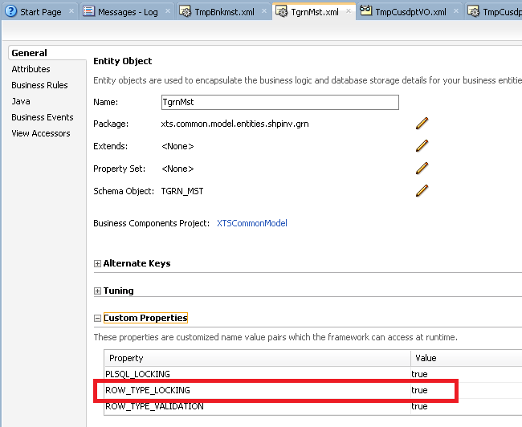

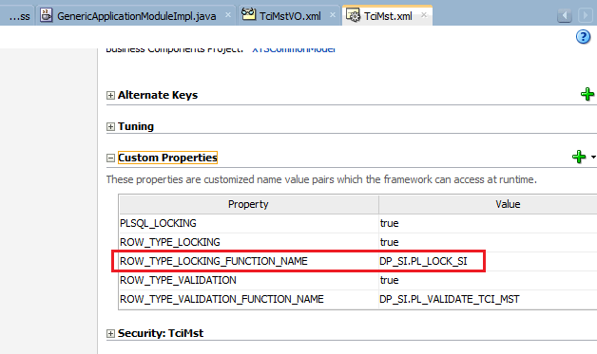

## 3.2 Prepare View Object

### 3.2.1 Create View Object

* For **common** View Object, create it under XTSCommonModel.
* For **specific** View Object used in each application, create it under the Model of each application
  + For Customer Department on XTSCusDpt - > xts.cusdpt.model.views - > TmpCusdptVO)

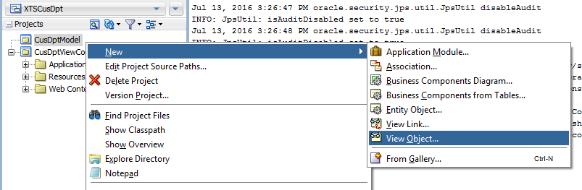

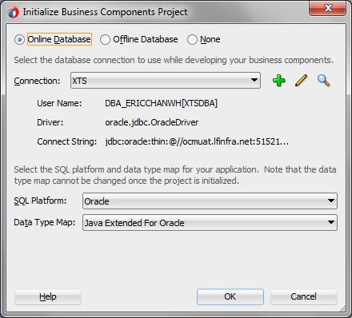

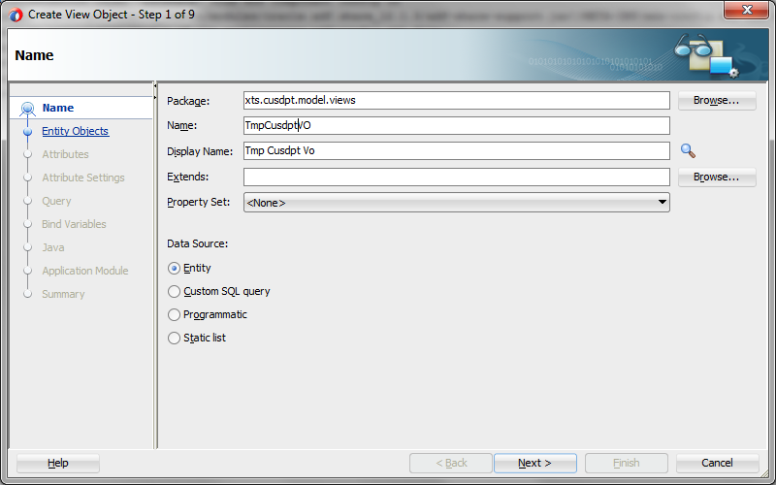

Select the EO

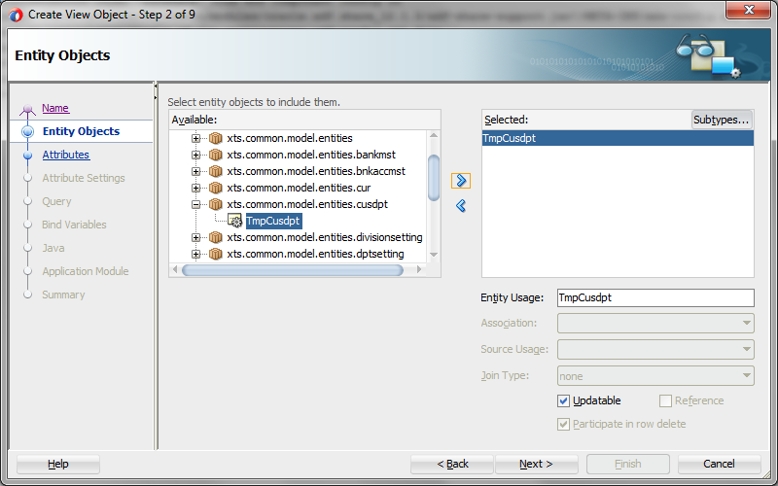

* Select the VO and press >. DO NOT select attribute and press >>

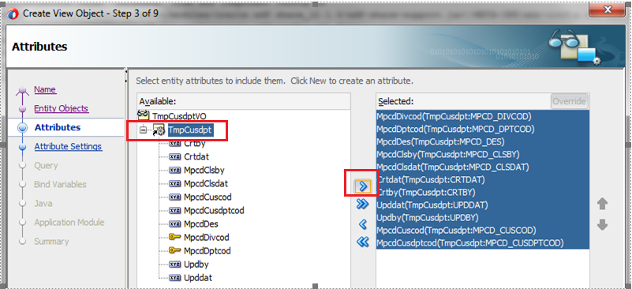

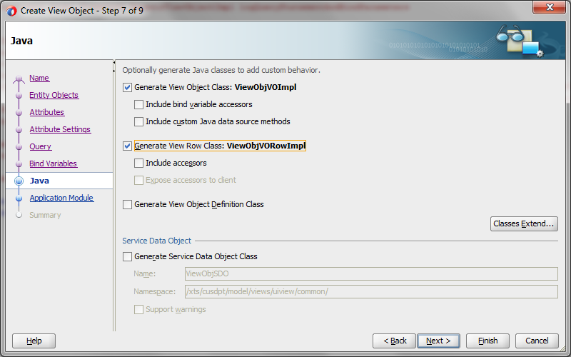

* Then press Classes Extend and change it as below

xts.common.model.framework.GenericViewObjectImpl

xts.common.model.framework.GenericViewRowImpl

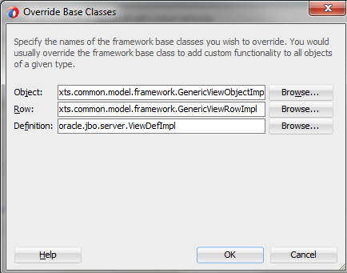

* You can create the Application Module now, i.e. xts.cusdpt.model.services. If not, it can be created separately.
  + If you want to create it separately, please refer to the next section

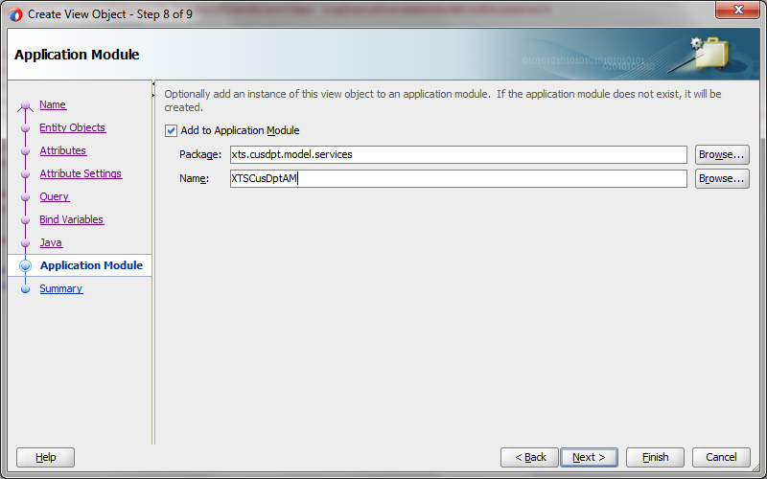

For other tabs, accept the default value. Here’s the outcome.

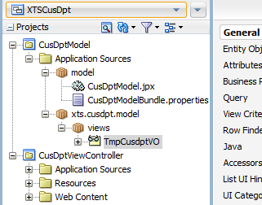

* Under the General Tab of the VO,
  + Add Custom Property “module”, For example, module = ME (XTS Module Code).
    - It will be used to check user permissions from TAP_AUTGRPATT.
    - Please follow the module code define in Oracle FORM
  + Add readonly, to control enable / disable of the field

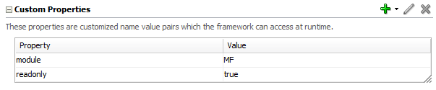

* Open the View Object -> Entity Object Page. Double check “Updateable” is selected.

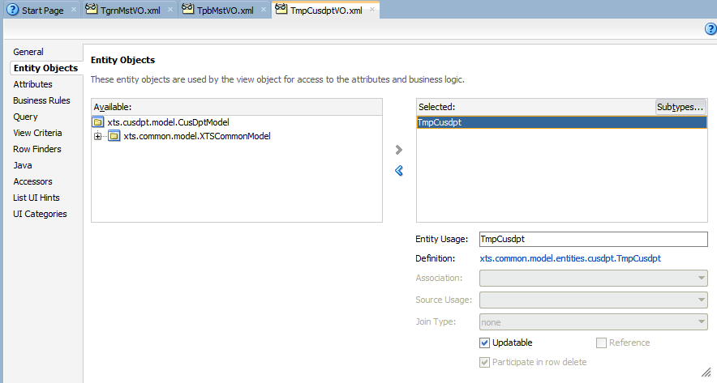

### 3.2.2 Disable Groovy File Generation

Model Setup (Need to double check if it is effective before VO created)

* De-selected “Groovy Expression Type Validation” + “Enable Groovy File Generation”

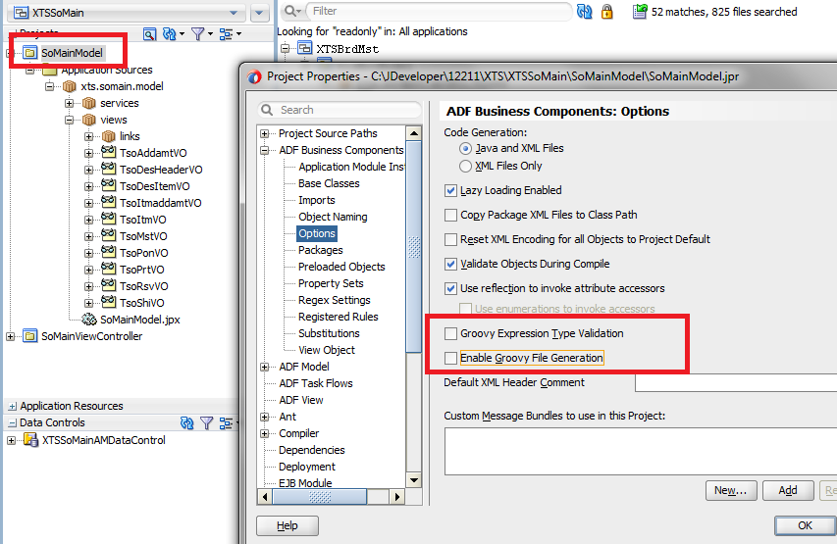

## 3.3 Prepare Application Module

### 3.3.1 Create Application Module

* If you have not created AM from View Object Setup Page, you can create it as below.

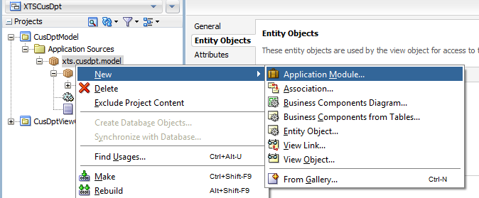

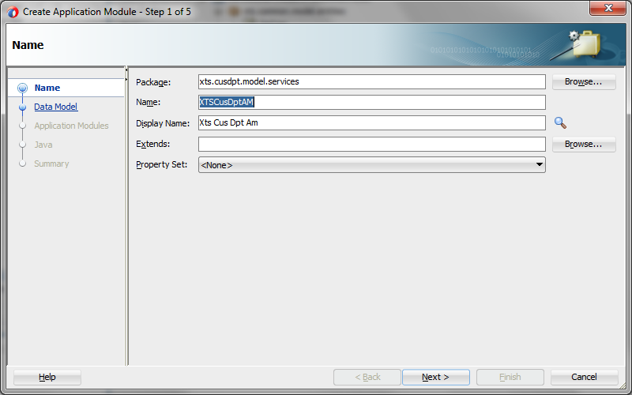

Rename the VO as below

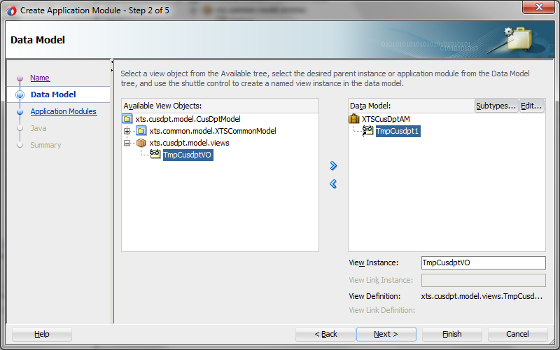

For other tab, accept it with “Next”to Finish

* (Need to try again to see the effect) Refactor (move) .jpx and bundle.properties

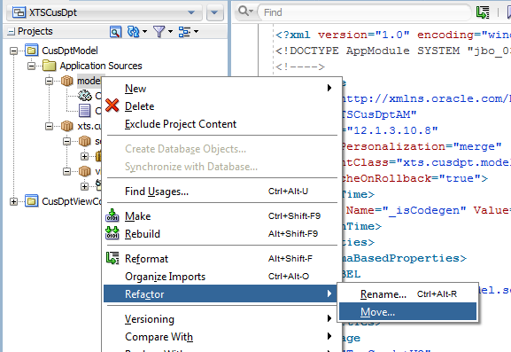

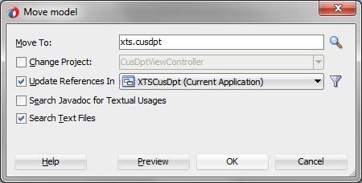

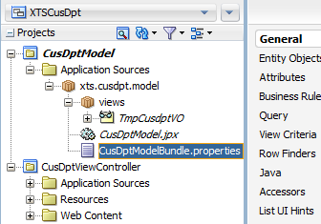

### 3.3.2 Update Application Module Setting

* Go to AM XTS$$$ModuleLocal
  + Go to Property Page
  + Add jbo.ampool.timetolive to this page first

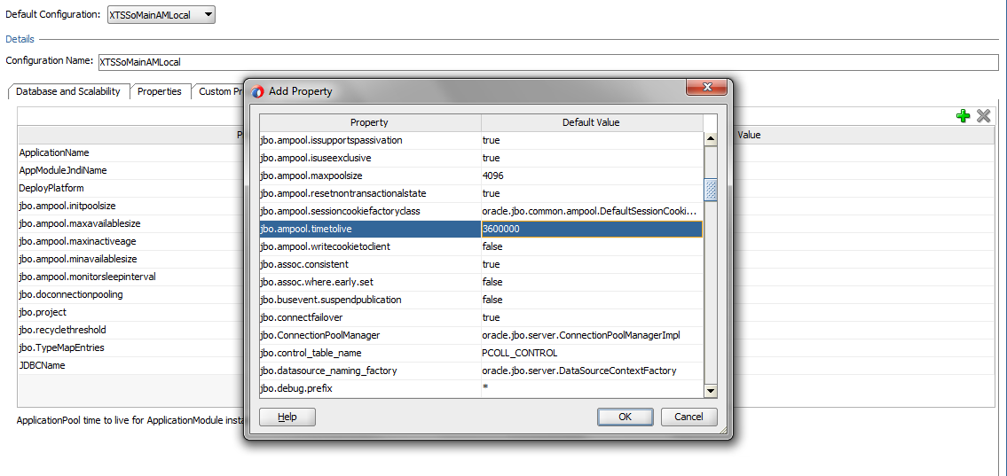

* Update the setting from this 2 page.

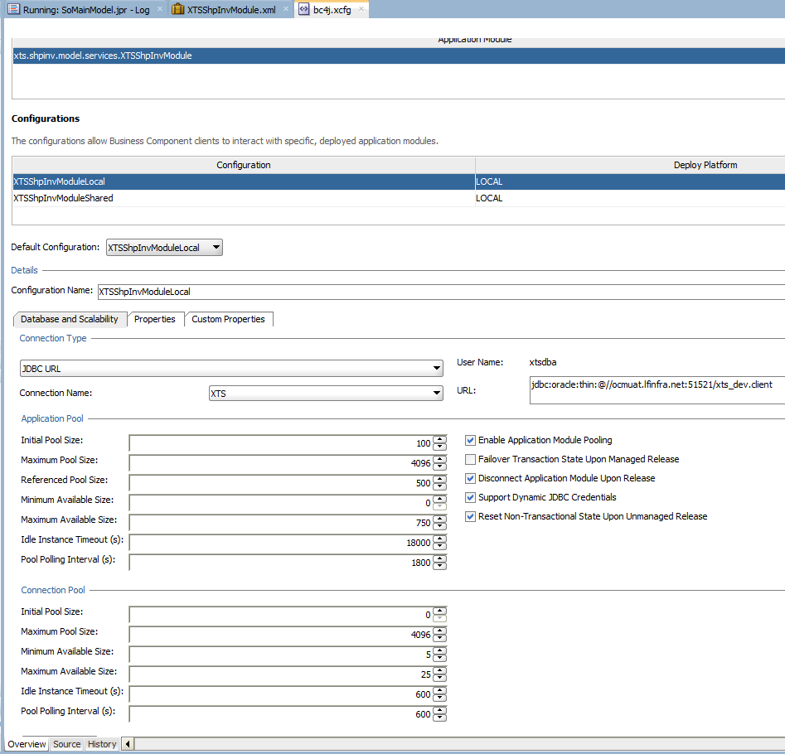

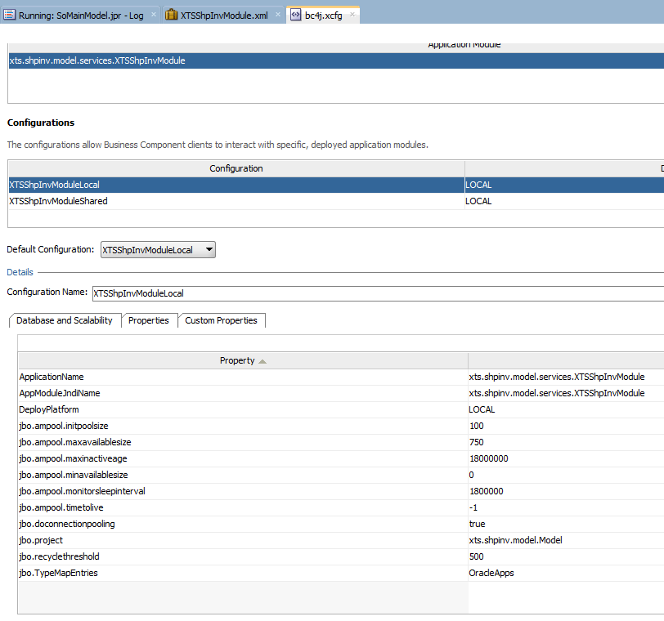

Go to source page

* Add this 2 line of code (In 12.1.3, it can be modified properly)

<Custom ns0:JDBCDataSource="jdbc/XTS" ns0:ns0="http://xmlns.oracle.com/bc4j/configuration" xmlns:ns0="http://xmlns.oracle.com/bc4j/configuration"/>

<Custom ns0:JDBCDataSource="java:comp/env/jdbc/XTSDS" xmlns:ns0="http://xmlns.oracle.com/bc4j/configuration"/>

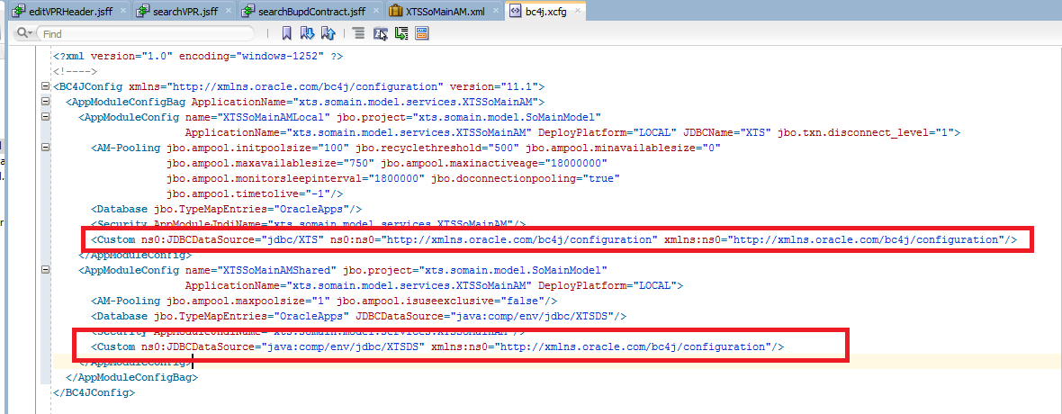

Go to AM Data Model Page

* Change Access Mode to RANGE_PAGING

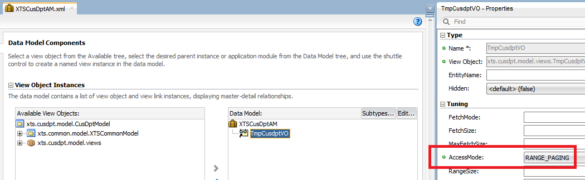

## 3.4 Update the Bases Classes

* Change ADF Business Components Base Classes to extend Generic Classes
* Right Click Model -> Project Property. Modify the Base classes as below

xts.common.model.framework.GenericPLSQLEntityImpl

xts.common.model.framework.GenericViewObjectImpl

xts.common.model.framework.GenericViewRowImpl

xts.common.model.framework.GenericApplicationModuleImpl

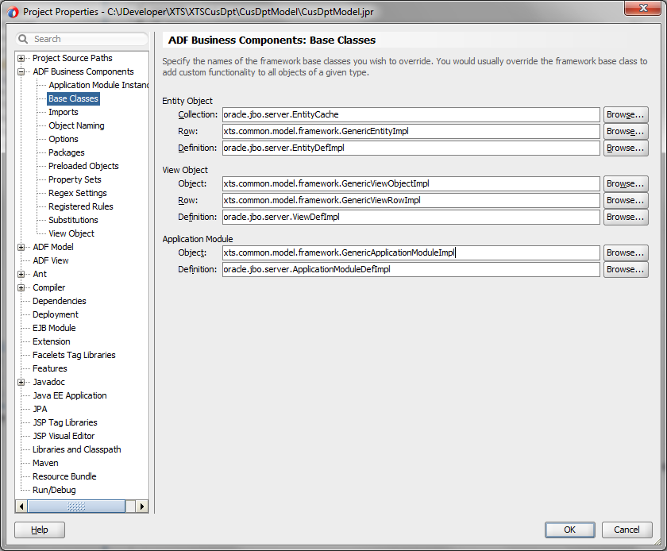

Check AM Implementation Class

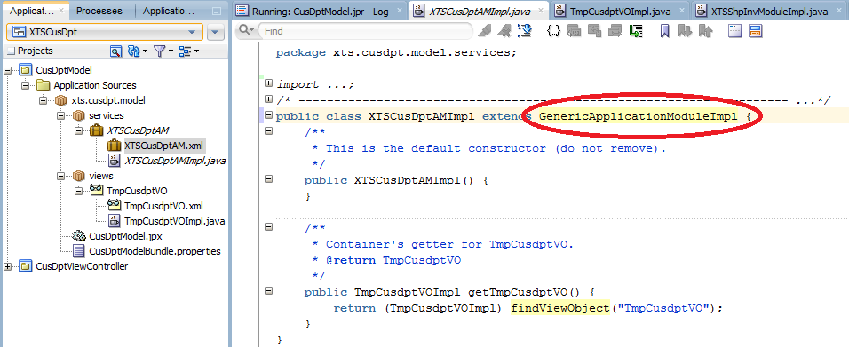

Check VO Implementation Class

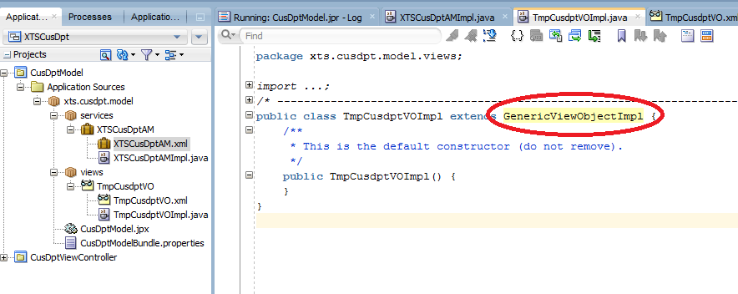

Check VO Row Implementation Class

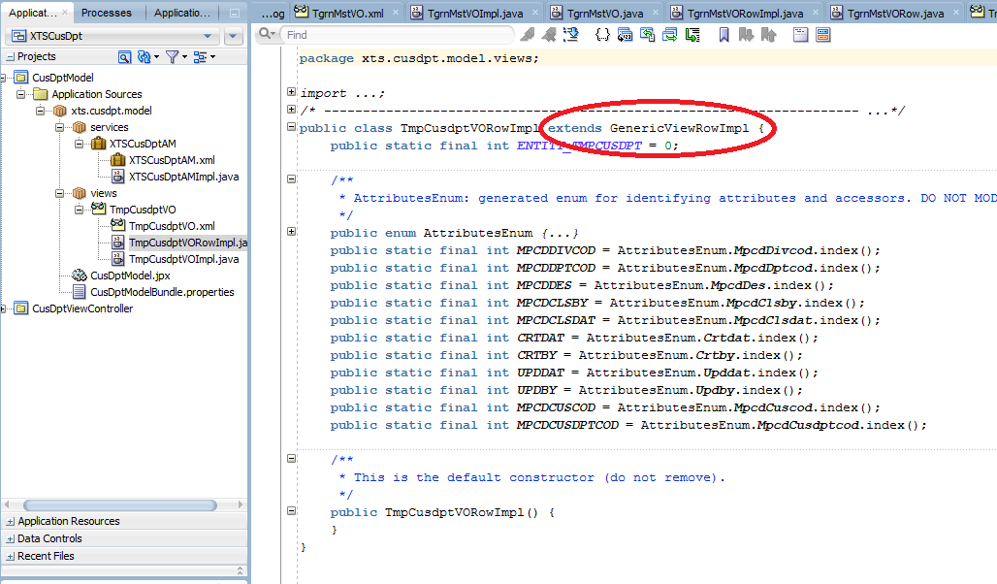

## 3.5 Test the Business Component through BC Tester

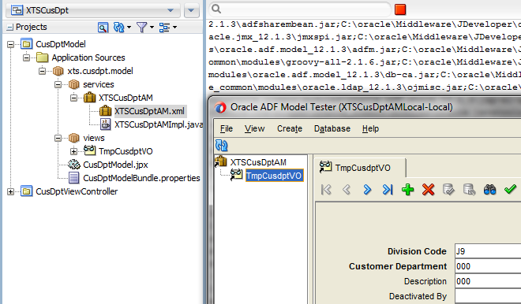

## 3.6 Prepare View Object (Continue from Section 3.2)

### 3.6.1 Add LOV into View Object

* Add List of Values (LOV)

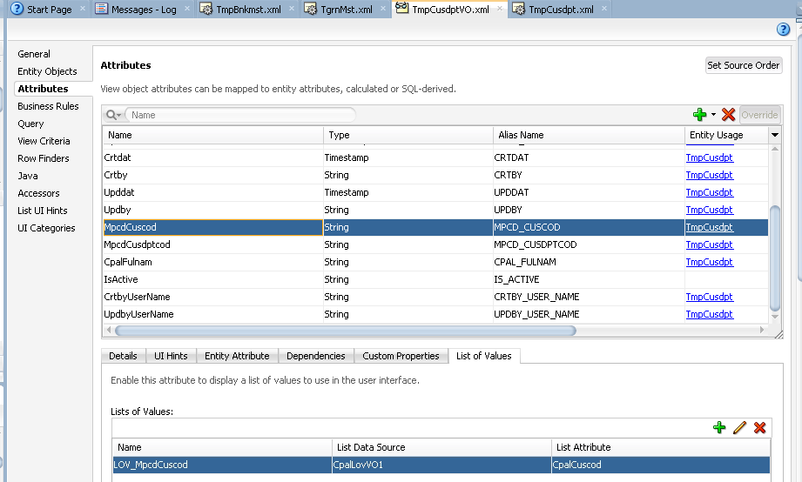

|  |  |
| --- | --- |
|  |  |

Sometimes if your LOV need to take current row value, such as division code as the input value, please go to View Accessor to set up it.

* If table filter need to show this LOV, set expression
  + return MpcdDivcod==null?adf.object.structureDef.getmpcdDivcodCoreVar():MpcdDivcod;
* If table filter DO NOT need to show this LOV, set value from pick down list
  + Simply pick MpcdDivcod from drop down list will be fine

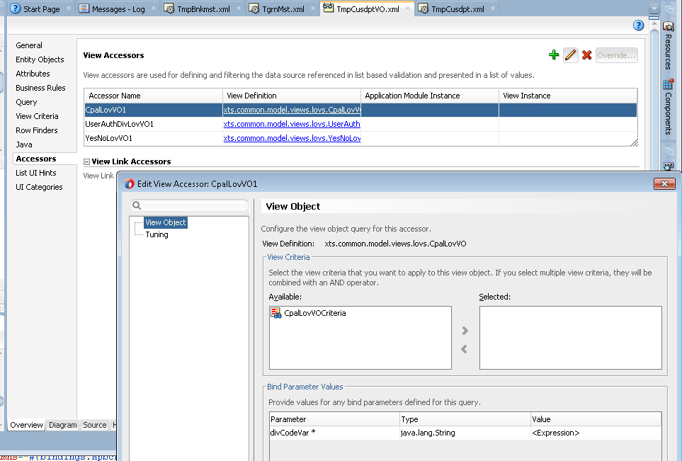

* For performance:
  + In View Object Source tab set ListRangeSize=”25” on LOV attributes, where List type are Combo Box, Combo Box with List of Values and Input Test with List of Values.
  + Default value is ListRangeSize=”-1” - it is mean to get all rows.   
    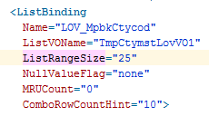
* Remember to Add Primary Key for LOV  
  LOV without PK will works incorrectly.

### 3.6.2 Add Description Attribute

3.6.2.1 Add Description Attribute which is based on SQL column in VO Attribute Page

* Create Transient attribute for description in Entity Object, e.g. Customer Full Name
* Put DP_DR.F_CPAL_FULNAM(XXX) is okay. DO NOT put SELECT DP_DR.F_CPAL_FULNAM(XXX) from DUAL

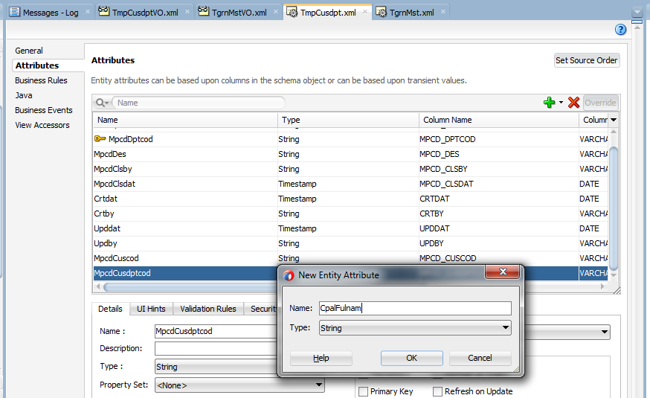

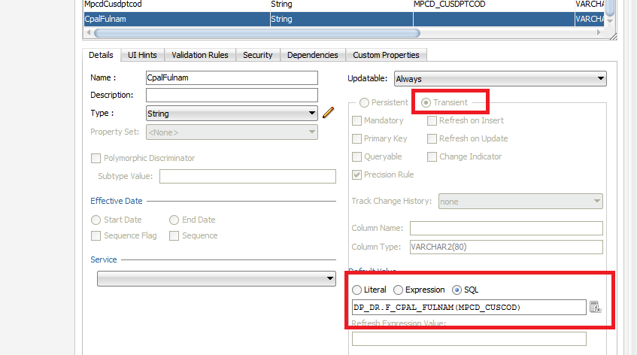

* Add Back the Transient EO Attribute into VO

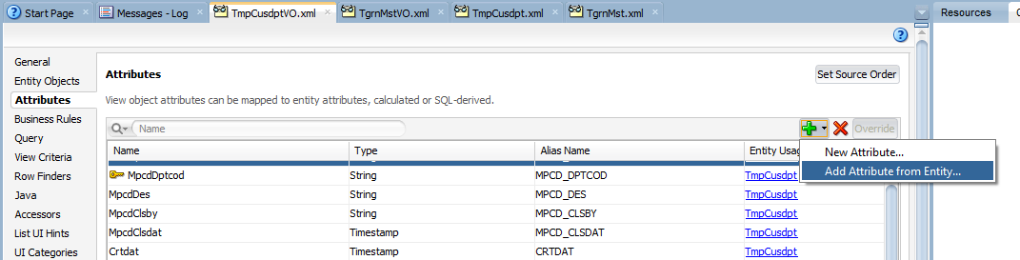

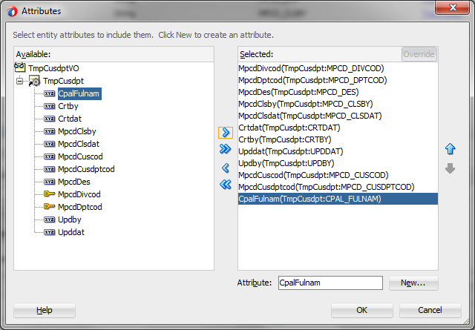

Another example adding Create By User Name / Update By User Name

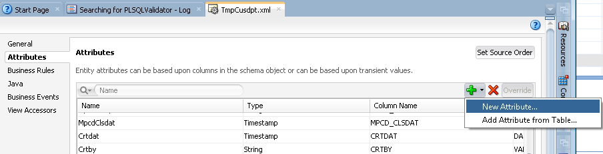

* Choose DataType

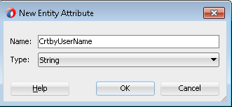

* Set field as Transient Attribute

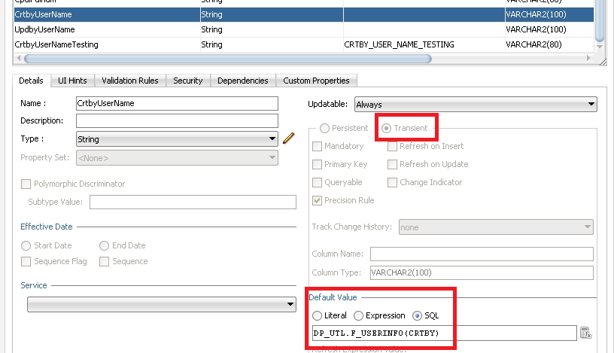

3.6.2.2 Add Description Attribute which is based on other EO (Association)

For example, you want to retrieve Supplier Name from GRN Supplier Code, there are 2 approaches

* Create a transient attribute and use SQL function to retrieve it
* Use Association to retrieve description from another EO

Step to use Association to retrieve description from another EO

* Check if Entity Object exists in Common Model

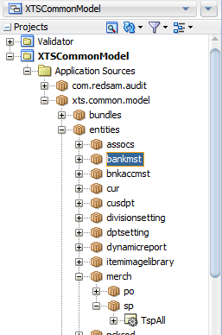

* Create an Association to link your current Module EO and Master EO
* ** Be careful on the File Path and the naming. Please follow the standard defined in 2.1 Structure for an ADF Application **

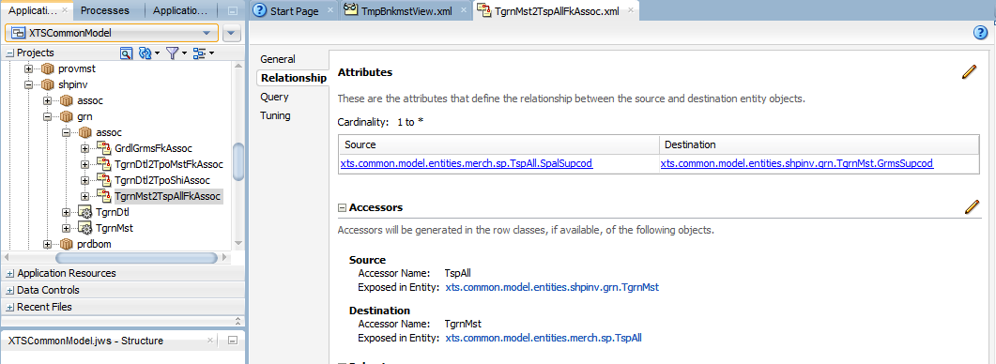

* Add the Entity Object, make sure you pick the correct Association and Join Type (in this case, my module use Left Outer Join)

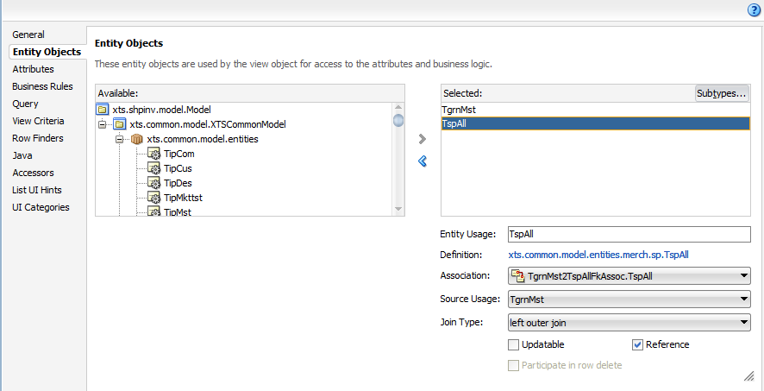

3.6.2.3 Add Description Attribute which is based on PL/SQL Validator

xxxxxx

3.6.2.4 Which approach should be used to show the description?

When should you use Association vs. EO Transient Attribute?

|  |  |  |
| --- | --- | --- |
| Description Type | Search | Edit |
| LOV Description e.g. Supplier LOV -> Code + Description | (On Retrieval) Association  [Since it don't need to consider closed date] | (On Retrieval) Association [Since it don't need to consider closed date] +  (On Change) Description will be extracted based on LOV VO |
| **Enquiry** Description from other table without logic e.g. Item Number in PB (2nd version) | (On Retrieval) Association  [Since it don't need to consider closed date] | Same as Search |
| **Enquiry** Description with logic, e.g. PL/SQL call, concatenate field e.g. GRN Status Description, Item Description in PB [Solve issue: (1) Keep the value after Save + Save & Close (2) Keep filter in search screen af:table] | (On Retrieval) EO Transient Attribute under master VO using PL/SQL Call i.e. Show Item Description (IPMS_DES1+2+3) - Add Transient Attribute in TPB_MST EO | Same as Search |

* + - (To be discussed) Create Transient attribute for special cases:
      * To use attribute in adf:table Filter, if this attribute use LOV and should be normal search in Filter.  
        Examle: TmpBnkmstView - > MpbkBnkcodSearch. In SQL field use columne name, then MpbkBnkcodSearch should be used in Filte table.

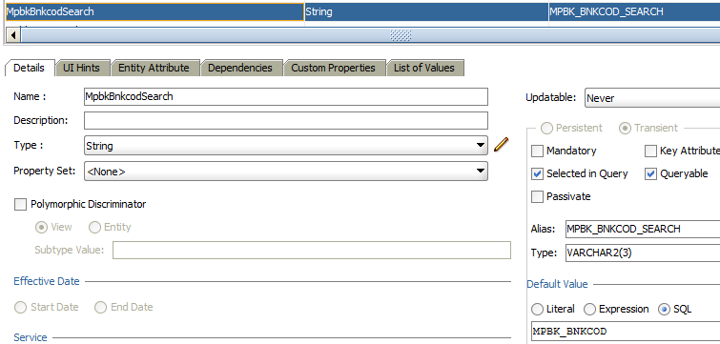

### 3.6.3 Add View Criteria into View Object

3.6.3.1 Setup Basic View Criteria and Advanced View Criteria

* Create View Criteria

On UI there are 2 searching area: Main search and Advanced Search. On VO we should create 2 View Criteria with the following pattern of naming, as **Core**… and **Adv**… (example: CoreTmpBnkmstViewCriteria and AdvTmpBnkmstViewCriteria). The Red highlight part is your VO name, e.g. TgrnMstVO

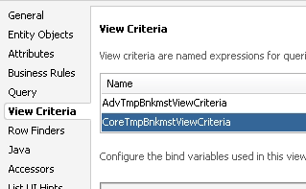

* In Basic View Criteria, add attributes which should be available in Query block.
  + For Division Code, always create a binding variable so that Main Menu division code can be passed from binding variable
  + For other fields, if you don’t need to modify the value, NO NEED to create bind variable.

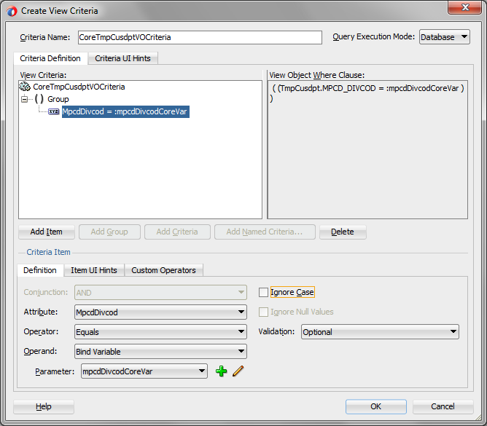

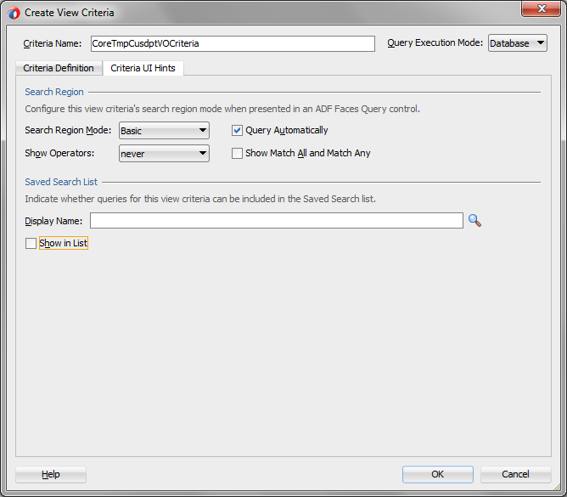

For Advanced Search, even for the same field, if you need to create binding variable, it need to be different from the Basic Search Binding Variable Name, such as mpcdDivcodCoreVar vs mpcdDivcodAdvVar

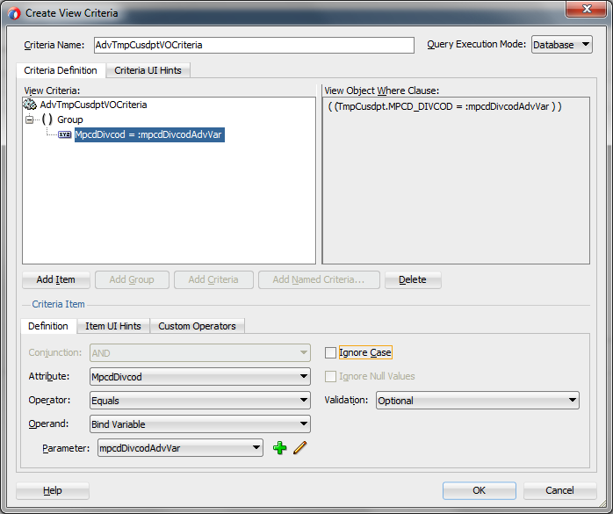

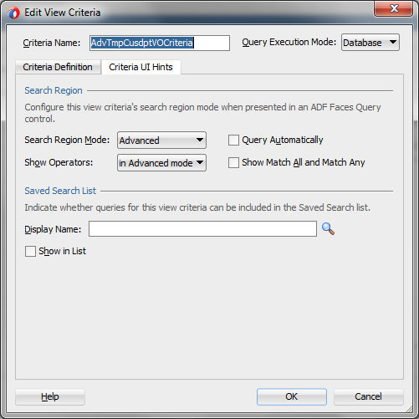

3.6.3.2 Add CHECK_DIV / CHECK_DPT Checking

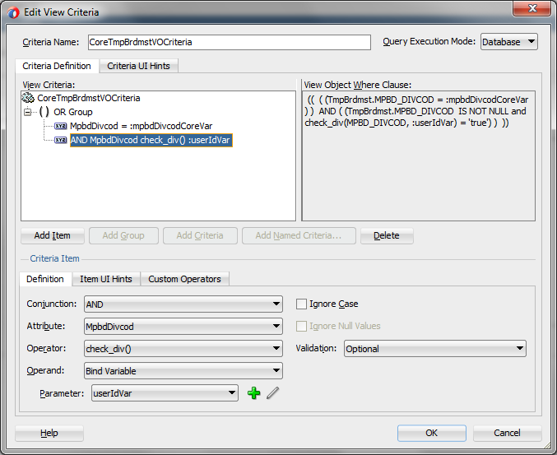

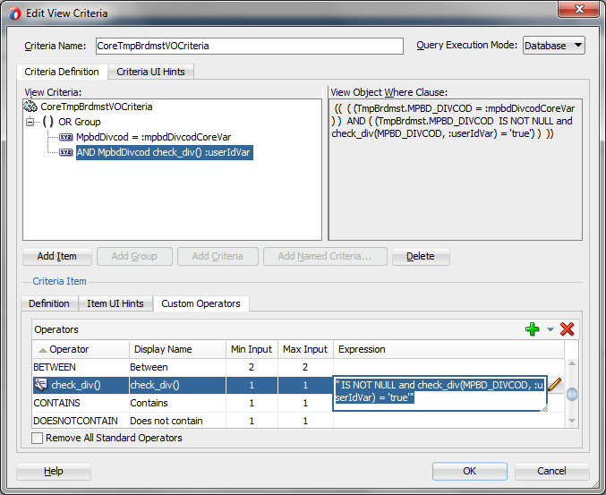

For this kind of fields which are not supposed for user input, go to “Item UI Hints” tab and set “Rendered Mode” to Never

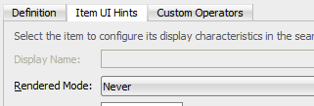

* Go back to Application Module.
* Set UserID Var as adf.object.applicationModule.getUserName()

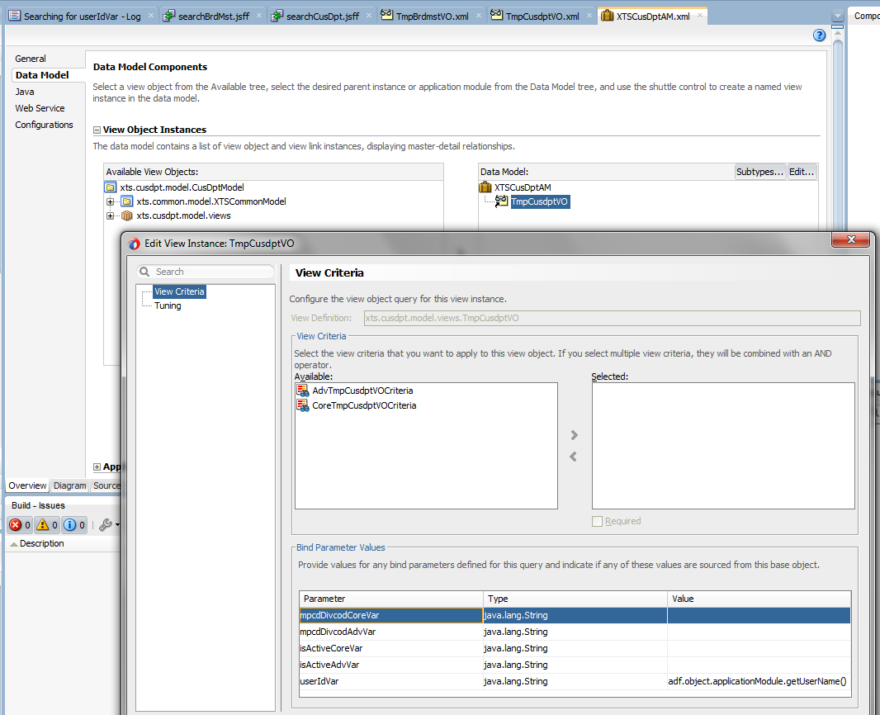

3.6.3.3 Special setting for WHERE clause using “PRMS_RUNNUM IN (SELECT xxx)

* You may talk to Eric for further explanation
* Create a transient attribute in master VO to hold the “Search” value

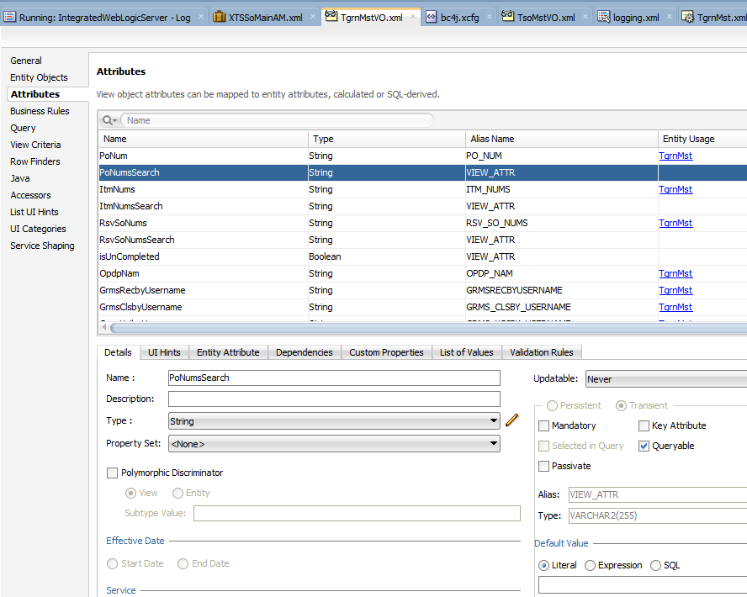

* From the newly created Transient attribute, create a new criteria item and use a bind variable to bind to it, e.g. poNumSearchCoreVar.

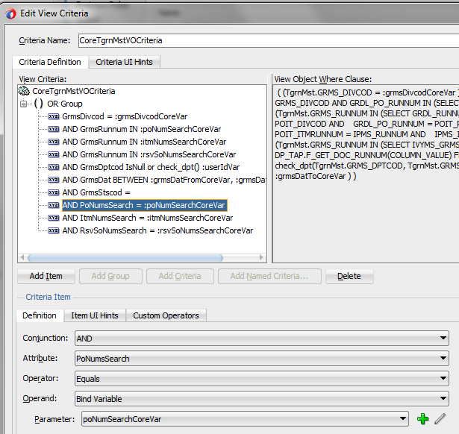

* Add New Criteria Item for using custom operator “IN”
* You may refer to XTSShpInv for the setup
  + This involves setup on “Definition” / “Item UI Hints” and “Custom Operators” page

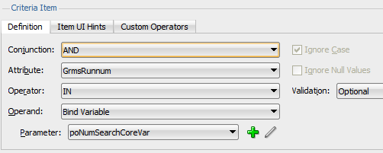

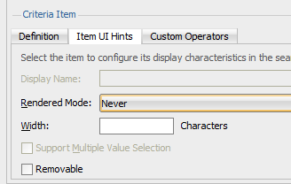

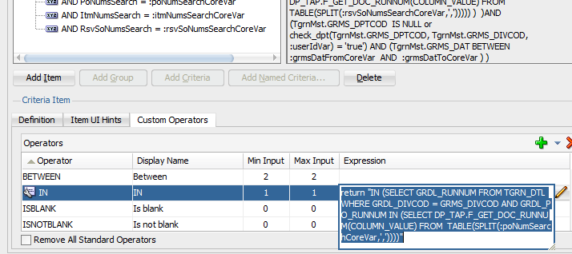

3.6.3.4 Add Basic View Criteria into AM Master View Object as default

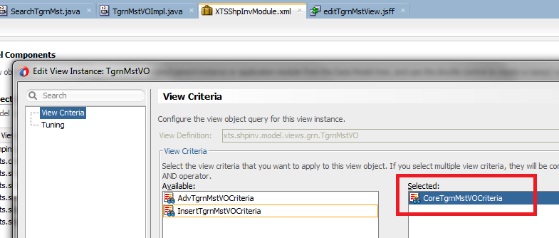

### 3.6.4 Generate View Object Class for View Object

* Only do it if you have not done it in previous section
* In Java Classes “Generate View Object Class” for custom method on VO level, and “Generate View Row Class” for custom methods in row level. To access method for clients – add methods to interface.  
  Example: generateBankCode, copyRow methods on TmpBnkmstViewImpl.java  
  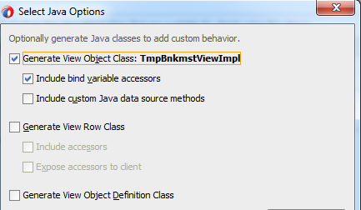

### 3.6.5 Create View Object for Insert Action

* For some complicated module, such as create record with a pop-up + default value, you need to create an insert VO
* For some simple module, don’t need to do this step. Please check with us before proceed.
* Add TgrnMstVO View Object to Application Module - > Data Model
* Rename to InsertTgrnMstVO  
  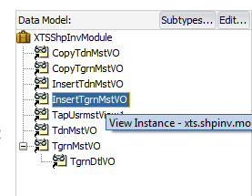
* Edit the view instance settings, check No Rows in Tuning tab  
  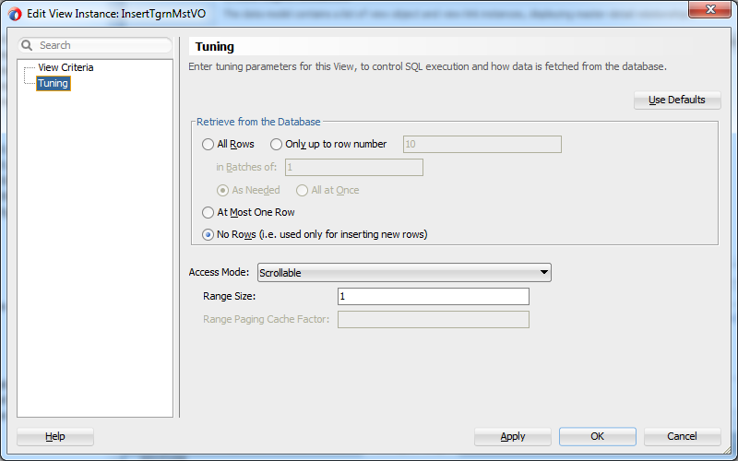
* Create View Criteria  
  
* Use attributes with Primary Key as a Criteria Items

For Bind Variable Name, please use another name, such as grmsDivcodInsertVar / grmsRunnumInsertVar

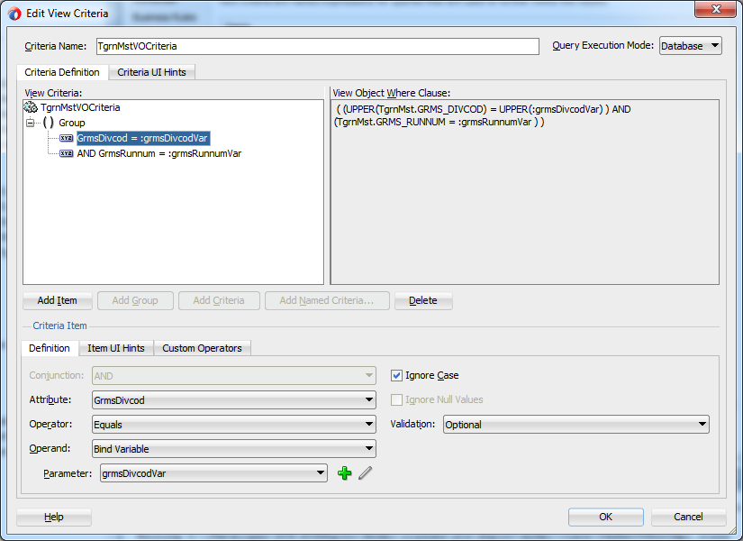

Then create 2 methods in Master VO Implementation Class. Please refer to that for detail.

* createTgrnMst – prepare the insert VO by taking the UI input parameter
* insertTgrnMst – actual method to execute the PL/SQL insert and filter the VO based on InsertViewCriteria

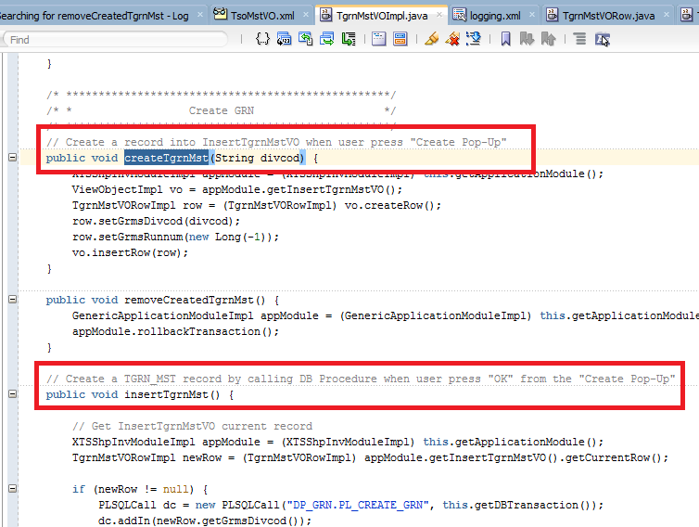

Or you may refer to SO Maintenance for one more example

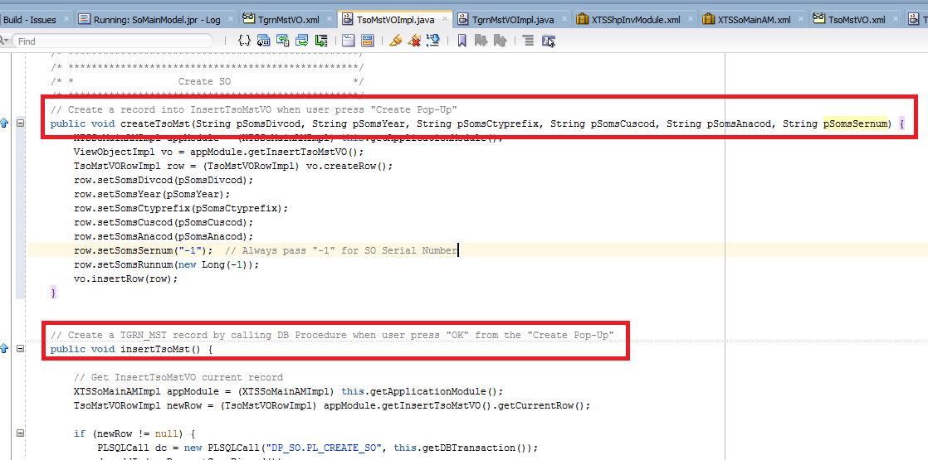

### 3.6.6 Create View Object for Copy Action (To be discussed with Aleksej)

* Create View Object for copy. For common using – on XTSCommonModel, or on specific application. (example: for Bank Master on XTSBankMaster - > xts.bnakmst.model.viewes - > CopyTmpBnkmstView)  
  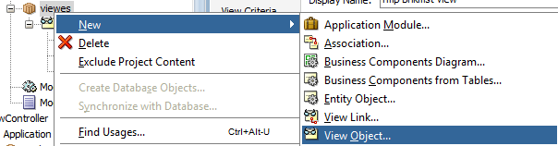
  + VO based Data Source – Custom SQL query.
    - In select statement use: select '' frm_mpbk_bnkcod, '' to_ mpbk_bnkcod from dual
    - Check Updatable: Always (for all attributes)
    - Check Mandatory and Queryable: true (for all attributes)
    - Check Data Type (set Java type and Oracle type, sometimes it isn’t possible to do through Overview mode, so please use Source tab and check Precision, Type, ColumnType, SQLType in all ViewAttribute).
    - In Java Classes “Generate View Object Class” for copyBnkmst method on VO level. And “Generate View Row Class” with “Include accessors” for accessor methods.   
      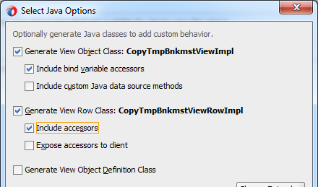
    - Create copyBnkmst method in CopyTmpBnkmstViewImpl class.

public void copyTmpBnkmst() {

CopyTmpBnkmstViewRowImpl row = (CopyTmpBnkmstViewRowImpl) this.getCurrentRow();

if (row != null) {

PLSQLCall dc = new PLSQLCall("DP_ADF_DNCN.PL_COPY_TMP_BNKMST", this.getDBTransaction());

dc.addIn(row.getFrmMpbkBnkcod());

dc.addIn(row.getToMpbkBnkcod());

dc.execute();

this.getApplicationModule().getTransaction().commit();

}

}

* + - To access method for clients– add methods to interface.  
      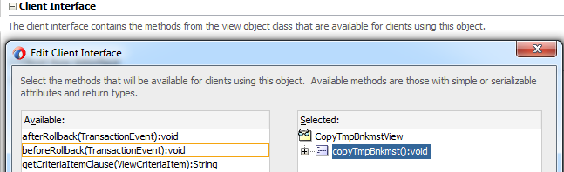
  + Add View Object to Application Module - > Data Model  
    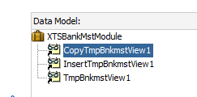

## 3.7 Create View Link

select replace(replace(initcap(r_constraint_name), '_',''), 'Pk')||'VOTo'||replace(initcap(table_name), '_','')||'VOLink' adf_view_link_name

, a.* from all_constraints@xtso.world a

where owner = 'XTSDBA'

and table_name like 'TSO%'

and constraint_name like '%_FK'

and r_constraint_name like '%PK'

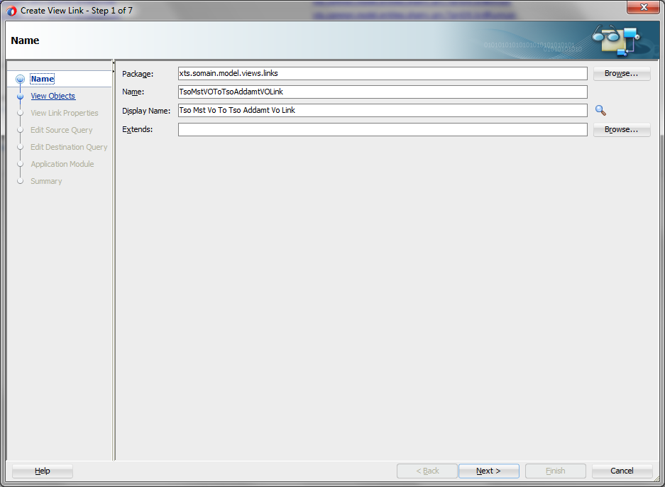

Choose Association (Be careful on Source and Destination), Press “Add” Button

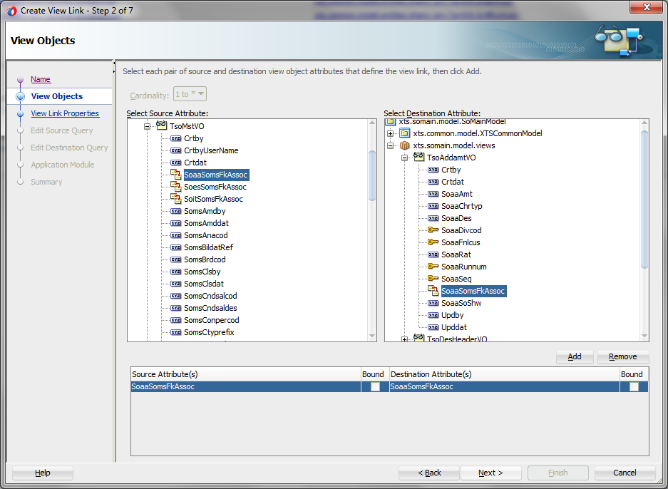

Leave it as default

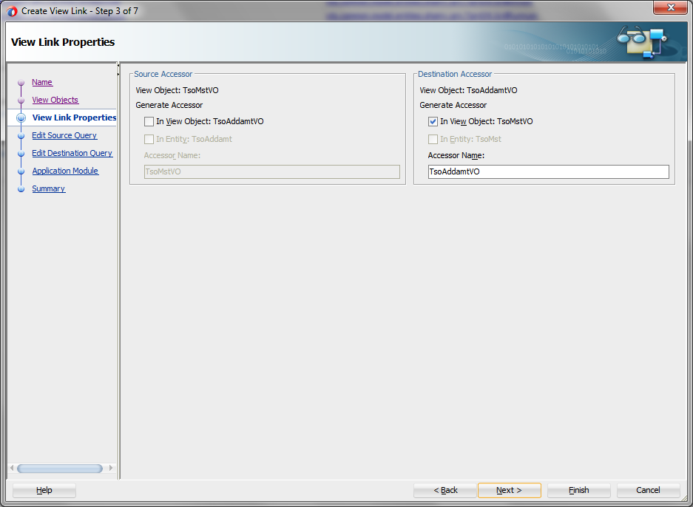

For other page, leave it as default

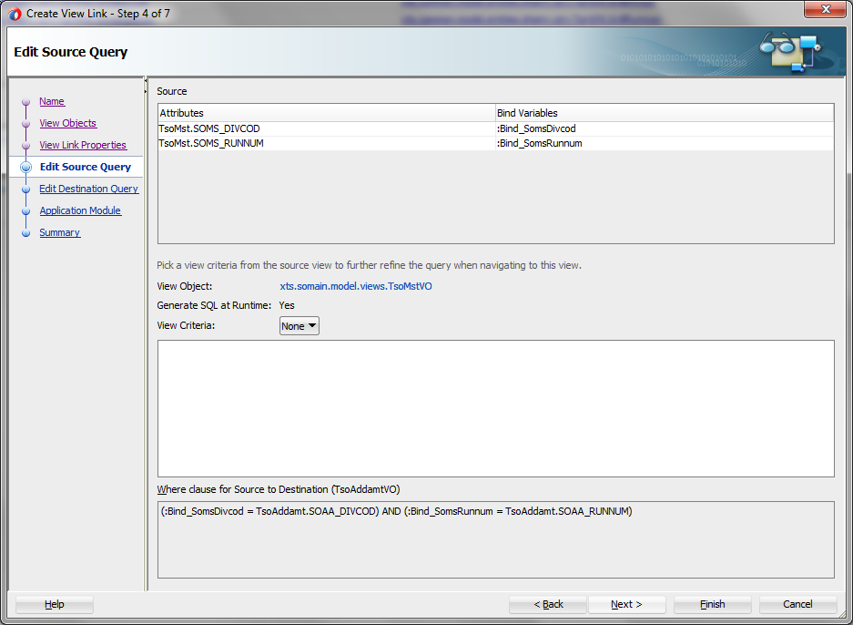

# 4. ADF View Controller

## 4.1 Task Flow Setup

### 4.1.1 Create Task Flow

* Be careful on the Package and Module Name. Please follow the standard in Structure for an ADF Application
  + Based on Template: xts-tf-template

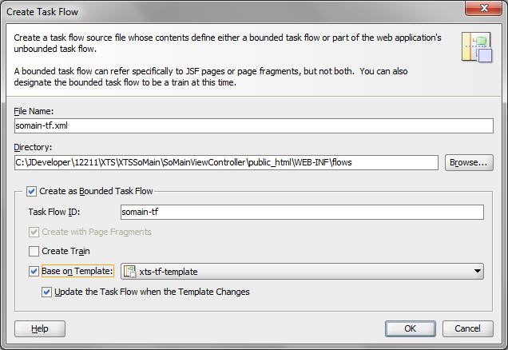

* Add View to Task Flow (recommended name: searchXxxView and editXxxView for common case)

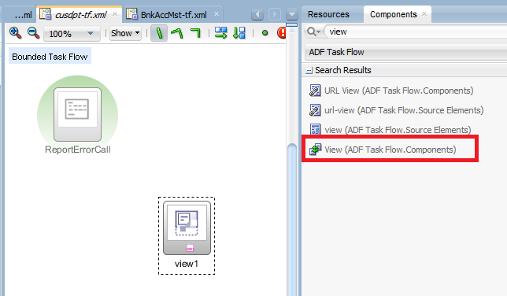

* Add Control View Case “Edit” and “Close” for navigation between Search Page and Edit Page for navigation

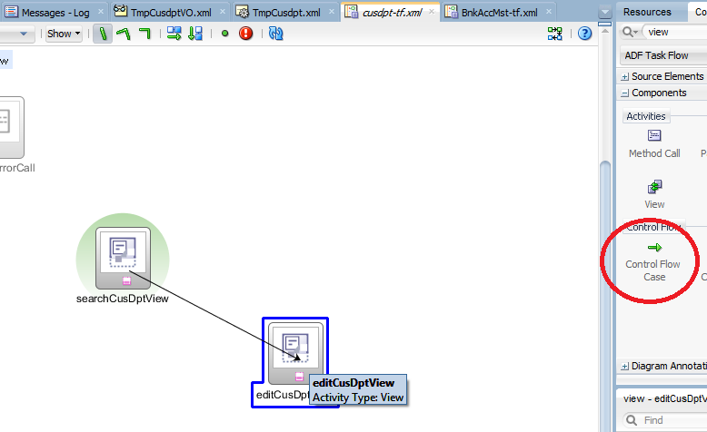

* Set Default Activity on searchView (Right Click Search View and set Default Activity)

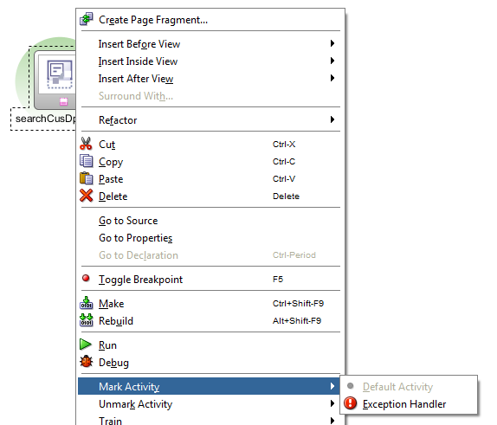

**Final Result**

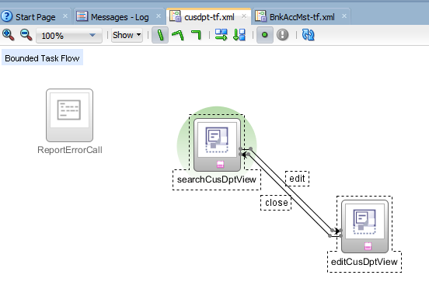

* Set Isolated Task Flow for the 1st entry task flow

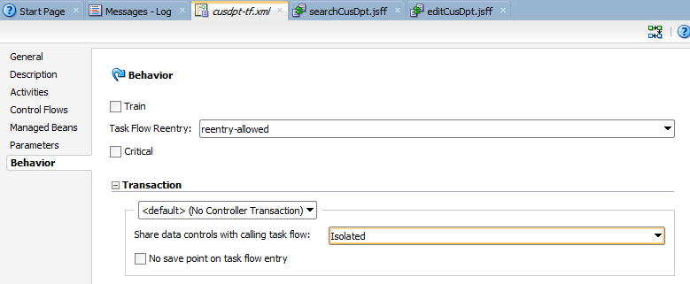

### 4.1.2 Setup Search Bean and Edit Bean for Task Flow

4.1.2.1 Create (1) Search Bean and (2) Edit Bean

Right Click Application Sources -> New -> Java Class

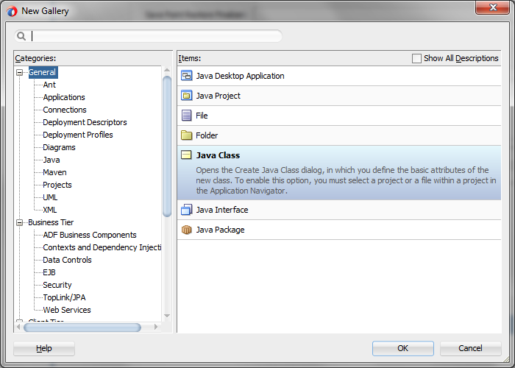

In latest 12.2.1.1, it need to specific extends:

Search Bean: Please try to extend xts.common.view.framework.beans.GenericSearch

Search Bean: Please try to extend xts.common.view.framework.beans.GenericEdit

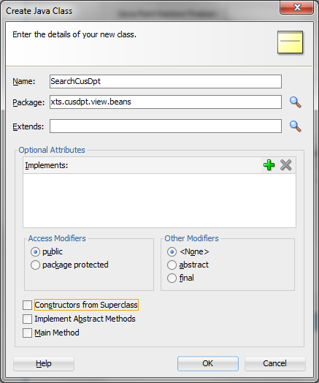

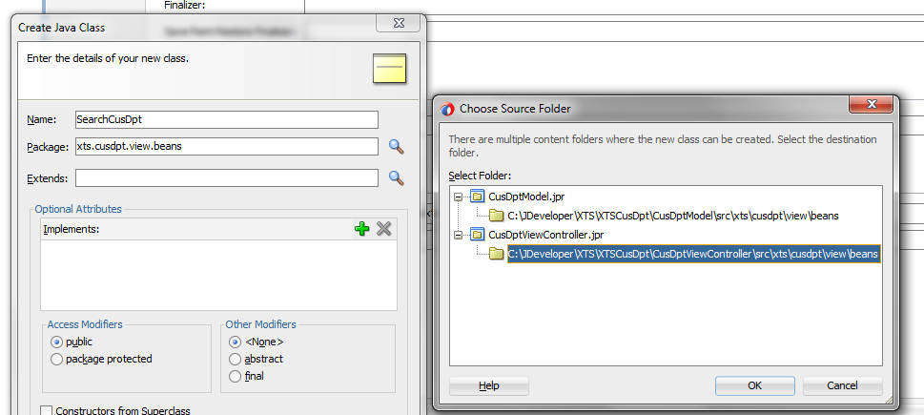

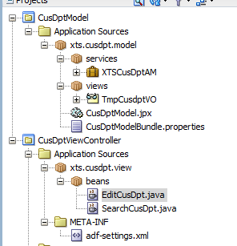

4.1.2.2 Add Search Bean and Edit Bean into Task Flow

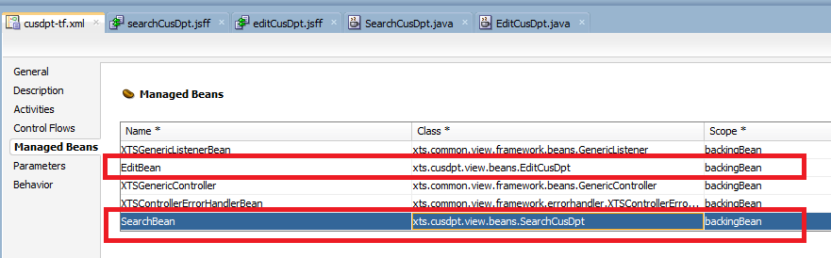

Revise Search Bean with your own VO and VC name

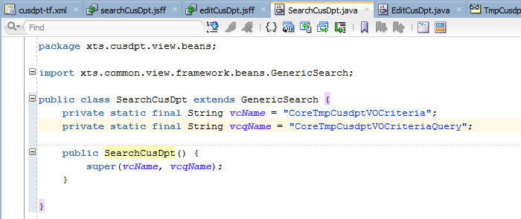

package xts.cusdpt.view.beans;

import javax.faces.application.FacesMessage;

import javax.faces.context.FacesContext;

import javax.faces.event.ActionEvent;

import oracle.adf.model.BindingContext;

import oracle.adf.model.binding.DCBindingContainer;

import oracle.adf.model.binding.DCIteratorBinding;

import oracle.jbo.ViewObject;

import xts.common.view.framework.beans.GenericSearch;

public class SearchCusDpt extends GenericSearch {

private static final String vcName = "CoreTmpCusdptVOCriteria";

private static final String vcqName = "CoreTmpCusdptVOCriteriaQuery";

public SearchCusDpt() {

super(vcName, vcqName);

}

}

Revise Edit Bean

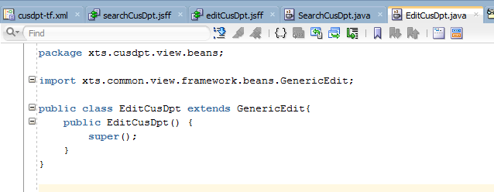

package xts.cusdpt.view.beans;

import xts.common.view.framework.beans.GenericEdit;

public class EditCusDpt extends GenericEdit{

public EditCusDpt() {

super();

}

}

## 4.2 Create Page Fragments for Search Page

### 4.2.1 Create Blank Page Fragment for the page

* Create ADF Page Fragments by double click on View from the task flow from previous section.
* Be careful on the Package and Module Name. Please follow the standard in Structure for an ADF Application

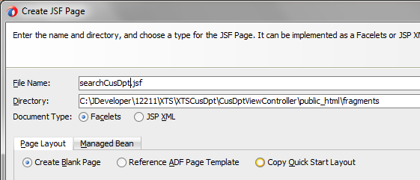

Result

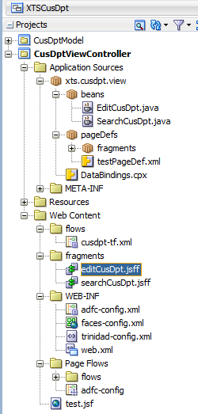

### 4.2.2 Apply Generic Template and Reusable Toolbar to the page

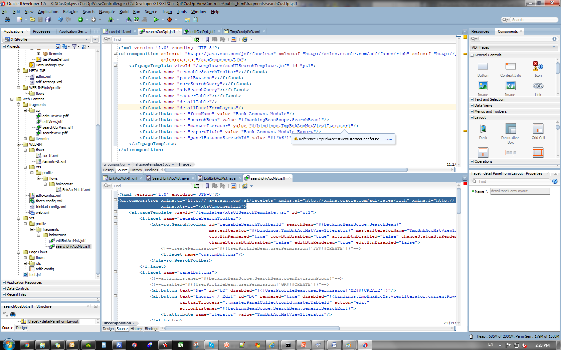

* For Search JSFF, Paste the template code as below and replace the Iterator Name, Module Name, etc..

<?xml version='1.0' encoding='UTF-8'?>

<ui:composition xmlns:ui="http://java.sun.com/jsf/facelets" xmlns:af="http://xmlns.oracle.com/adf/faces/rich" xmlns:f="http://java.sun.com/jsf/core"

xmlns:xts-rc="/xtsComponentLib">

<af:pageTemplate viewId="/templates/xtsUISearchTemplate.jsf" id="pt1">

<f:facet name="reusableSearchToolbar">

<xts-rc:SearchToolbar id="reusableSearchToolbarId" searchBean="#{backingBeanScope.SearchBean}"

masterIterator="#{bindings.TmpCusdptVOIterator}" masterIteratorName="TmpCusdptVOIterator"

actionBtnRendered="true" actionBtnDisabled="false"

copyBtnRendered="true" copyBtnDisabled="#{!UserProfileBean.userPermission['??###CREATE']}"

changeStatusBtnRendered="true" changeStatusBtnDisabled="false"

editBtnRendered="true" editBtnDisabled="#{!UserProfileBean.userPermission['??###VIEW']}"

createBtnRendered="true" createBtnDisabled="#{!UserProfileBean.userPermission['??###CREATE']}"

deleteBtnRendered="true" deleteBtnDisabled="#{!UserProfileBean.userPermission['??###DELETE']}">

<f:facet name="customButtons"/>

</xts-rc:SearchToolbar>

</f:facet>

<f:facet name="customCommandMenuItems"/>

<f:facet name="coreSearchQuery">

</f:facet>

<f:facet name="advSearchQuery">

</f:facet>

<f:facet name="masterTable">

</f:facet>

<f:facet name="detailTable"/>

<f:facet name="detailPanelFormLayout"/>

<f:attribute name="formName" value="Customer Department Module"/>

<f:attribute name="searchBean" value="#{backingBeanScope.SearchBean}"/>

<f:attribute name="masterIterator" value="#{bindings.TmpCusdptVOIterator}"/>

<f:attribute name="exportTitle" value="Customer Department Export"/>

<f:attribute name="panelButtonsStretchId" value="#{'b6'}"/>

<f:attribute name="masterIteratorName" value="TmpCusdptVOIterator"/>

<f:attribute name="createBtnRendered" value="true"/>

<f:attribute name="createBtnDisabled" value="#{!UserProfileBean.userPermission['??###CREATE']}"/>

<f:attribute name="exportBtnDisabled" value="false"/>

<f:attribute name="editBtnRendered" value="true"/>

<f:attribute name="editBtnDisabled" value="#{!UserProfileBean.userPermission['??###VIEW']}"/>

<f:attribute name="splitterPosition" value="370"/>

</af:pageTemplate>

</ui:composition>

### 4.2.3 Add table into the Search Page as af:Table

Drag Data Control to Master Table Facet to create the searching table

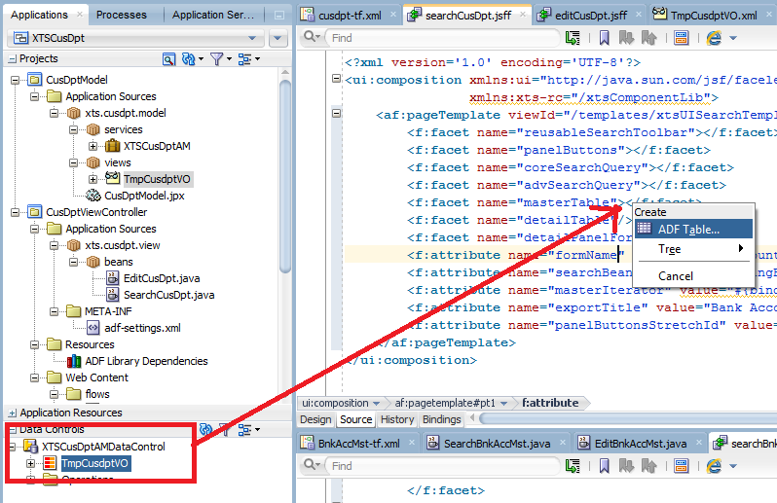

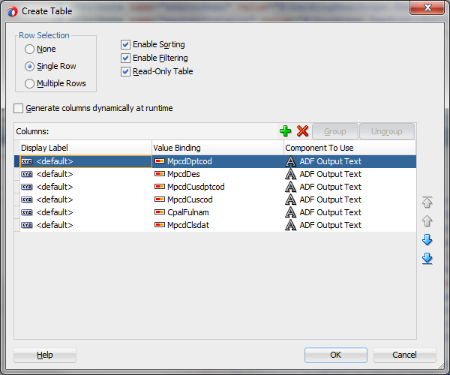

Refactor Search Page Page Defintion to

* C:\JDeveloper\XTS\XTSCusDpt\CusDptViewController\src\xts\cusdpt\view\pageDefs\fragments

Refactor DataBinding.cpx to

* C:\JDeveloper\XTS\XTSCusDpt\CusDptViewController\src\xts\cusdpt\view

Update other attribute value, such as formName, searchBean, masterIterator, etc…

Result

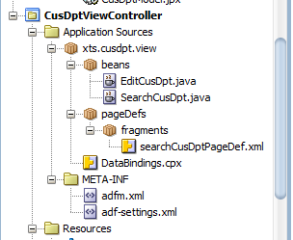

After you drag and drop the af:table on the search page, please modify the af:table parameter as below. You may copy and paste the whole code and replace with your own VO name, etc..

<af:table value="#{bindings.TmpCusdptVO.collectionModel}" var="row" rows="#{bindings.TmpCusdptVO.rangeSize}"

emptyText="#{bindings.TmpCusdptVO.viewable ? 'No data to display.' : 'Access Denied.'}" rowBandingInterval="0"

selectedRowKeys="#{bindings.TmpCusdptVO.collectionModel.selectedRow}"

selectionListener="#{bindings.TmpCusdptVO.collectionModel.makeCurrent}" rowSelection="single"

fetchSize="#{bindings.TmpCusdptVO.rangeSize}" filterModel="#{bindings.TmpCusdptVOQuery.queryDescriptor}"

queryListener="#{bindings.TmpCusdptVOQuery.processQuery}" filterVisible="true" varStatus="vs" id="masterTableId" scrollPolicy="page"

binding="#{backingBeanScope.SearchBean.masterTable}" selectionEventDelay="enabled" columnStretching="column:c2"

contentDelivery="immediate"

first="#{pageFlowScope.TmpCusdptVOIteratorRangeStart eq null ? 0 : pageFlowScope.TmpCusdptVOIteratorRangeStart}"

summary="Customer Department">

### 4.2.4 Add View Criteria into Page as af:Query

* Drag the (1) Core and (2) Advanced View Criteria into coreSearchQuery and advSearchQuery facet

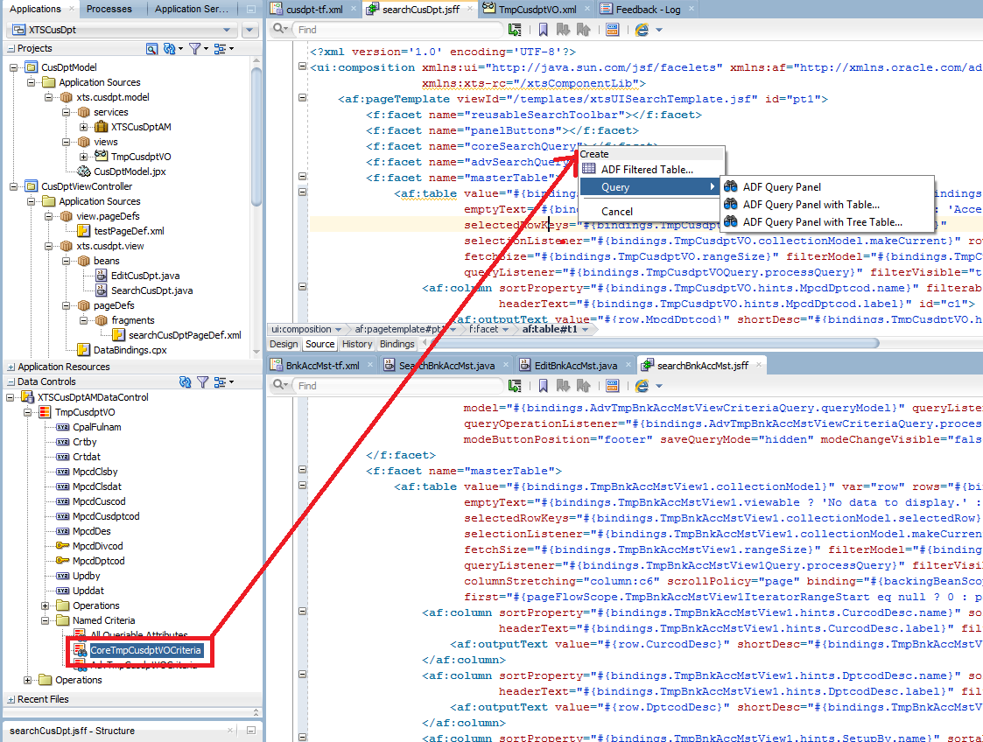

**For Basic & Advanced Search**

After drag and drop, remove the extra component as below.

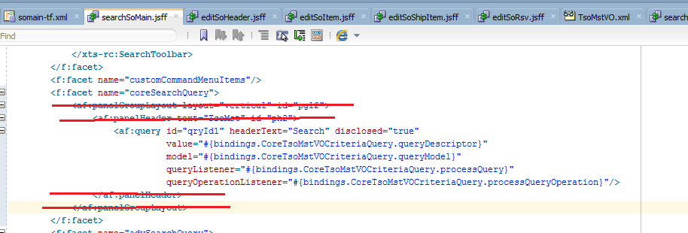

**For Basic Search**

Change ID and update the binding similar to below example.

<af:query id="coreSearchQueryId" headerText="Search"

value="#{bindings.CoreTmpBrdmstVOCriteriaQuery.queryDescriptor}"

model="#{bindings.CoreTmpBrdmstVOCriteriaQuery.queryModel}"

queryListener="#{bindings.CoreTmpBrdmstVOCriteriaQuery.processQuery}"

queryOperationListener="#{bindings.CoreTmpBrdmstVOCriteriaQuery.processQueryOperation}"

saveQueryMode="hidden" modeChangeVisible="false" disclosed="true" styleClass="advancedQuery"

rows="1" maxColumns="2" binding="#{backingBeanScope.SearchBean.queryCore}" displayMode="simple"/>

**For Advanced Search**

Change ID and update the binding similar to below example.

<af:query id="advSearchQueryId" headerText="Search" disclosed="true"

value="#{bindings.AdvTmpBrdmstVOCriteriaQuery.queryDescriptor}"

model="#{bindings.AdvTmpBrdmstVOCriteriaQuery.queryModel}"

queryListener="#{bindings.AdvTmpBrdmstVOCriteriaQuery.processQuery}"

queryOperationListener="#{bindings.AdvTmpBrdmstVOCriteriaQuery.processQueryOperation}"

maxColumns="1" displayMode="default" modeButtonPosition="footer" saveQueryMode="hidden"

modeChangeVisible="false" styleClass="advancedQuery"/>

Update Page Definition only for Advanced View Criteria as below

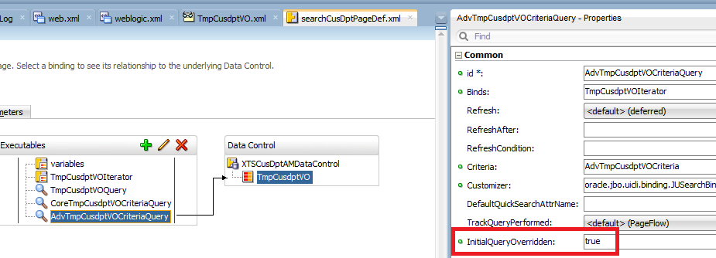

### 4.2.6 Prevent 2 times refresh on Master VO

* Please include a hidden input text before the Toolbar
* Refer to XA-1345 for detail

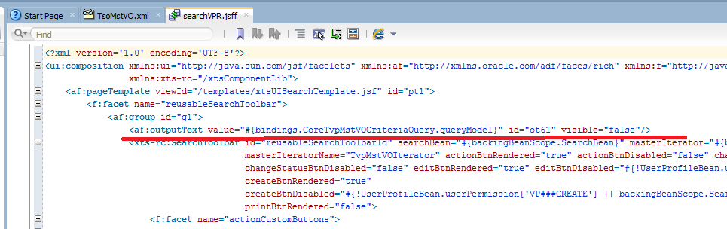

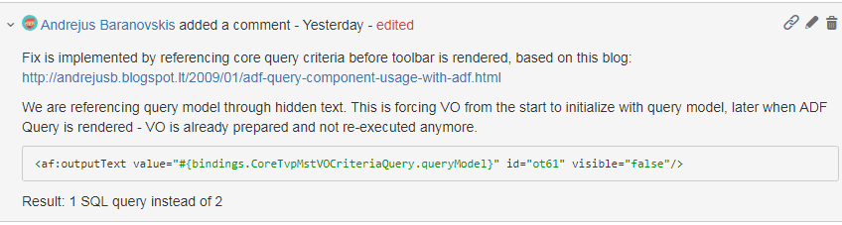

### 4.2.7 Other Basic Setup

## 4.3 Create Page Fragments for Edit Page

### 4.3.1 Create Blank Page Fragment for the page

* Please follow previous instruction to create a blank page fragment

### 4.3.2 Apply Generic Template and Reusable Toolbar to the page

* For Edit JSFF, Paste the template code as below and replace the Iterator Name, Module Name, etc..

<?xml version='1.0' encoding='UTF-8'?>

<ui:composition xmlns:ui="http://java.sun.com/jsf/facelets" xmlns:af="http://xmlns.oracle.com/adf/faces/rich" xmlns:f="http://java.sun.com/jsf/core"

xmlns:xts-rc="/xtsComponentLib">

<af:pageTemplate viewId="/templates/xtsUIEditTemplate.jsf" id="pt1">

<f:facet name="reusableEditToolbar">

<xts-rc:EditToolbar id="et1" editBean="#{backingBeanScope.EditBean}" masterIteratorName="TmpCusdptVOIterator"

attributeHitsDisabled="#{bindings.MpcdDptcod.hints.disabled}"

editBtnDisabled="#{!UserProfileBean.userPermission['??###EDIT']}">

<f:facet name="customButtons"/>

</xts-rc:EditToolbar>

</f:facet>

<f:facet name="decorativeBoxArea">

</f:facet>

<f:facet name="panelBoxToolbar"/>

<f:facet name="panelBoxArea"/>

<f:attribute name="formName" value="Customer Department Module"/>

<f:attribute name="editBean" value="#{backingBeanScope.EditBean}"/>

</af:pageTemplate>

</ui:composition>

### 4.3.3 Add table into the Search Page as af:Table

* Drag the Data Control as ADF Form into decorativeBoxArea facet

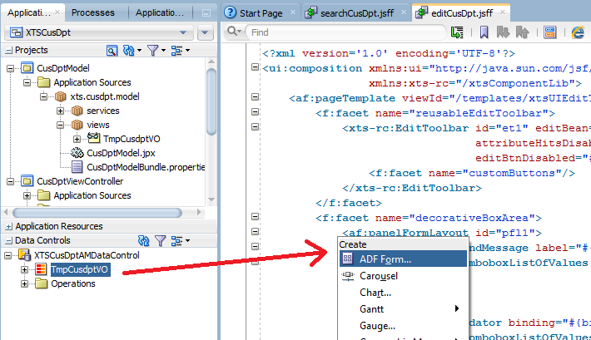

### 4.3.4 Other Basic Setup

Go back to Page Definition of Edit Page

* Add action Commit and Rollback

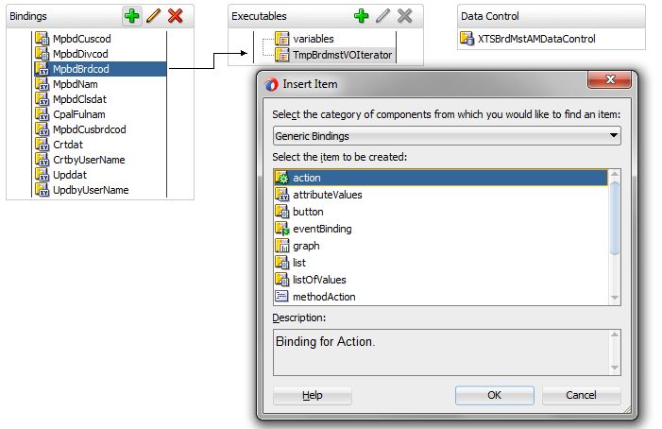

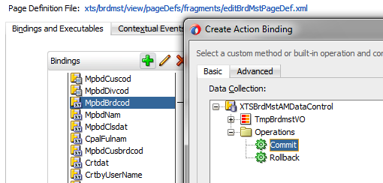

## 4.4 Create Page Fragments for Test Page

Create Test Page under C:\JDeveloper\XTS\XTSCusDpt\CusDptViewController\public_html

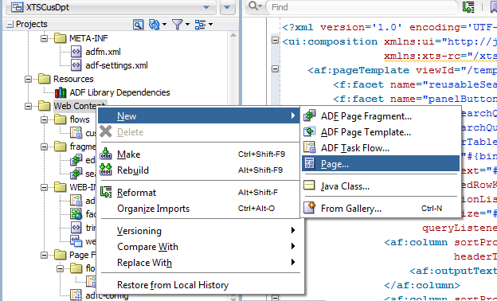

Copy Javascript to test.jsf

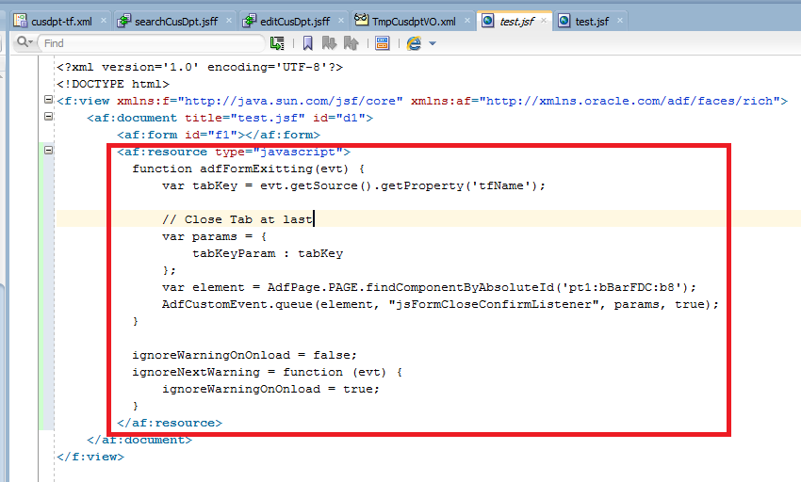

Drag Task Flow inside the af:form

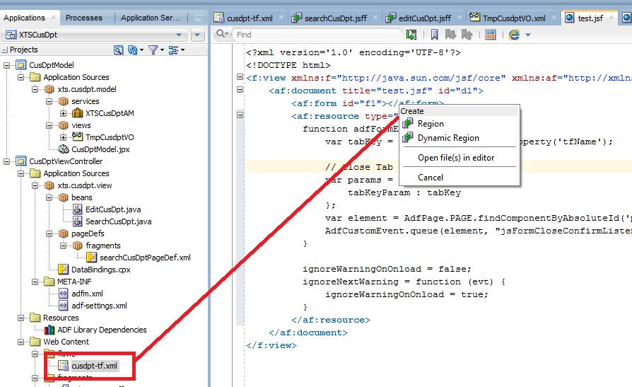

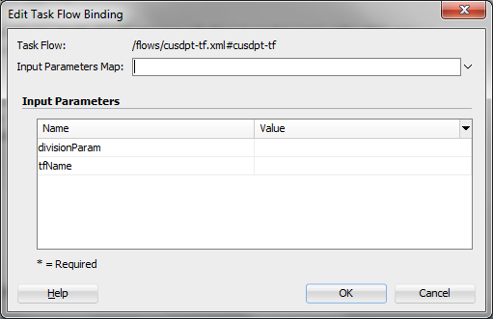

* Set default division parameter as “EDP”
* This will override later by passing parameter from Main Menu to this Task Flow

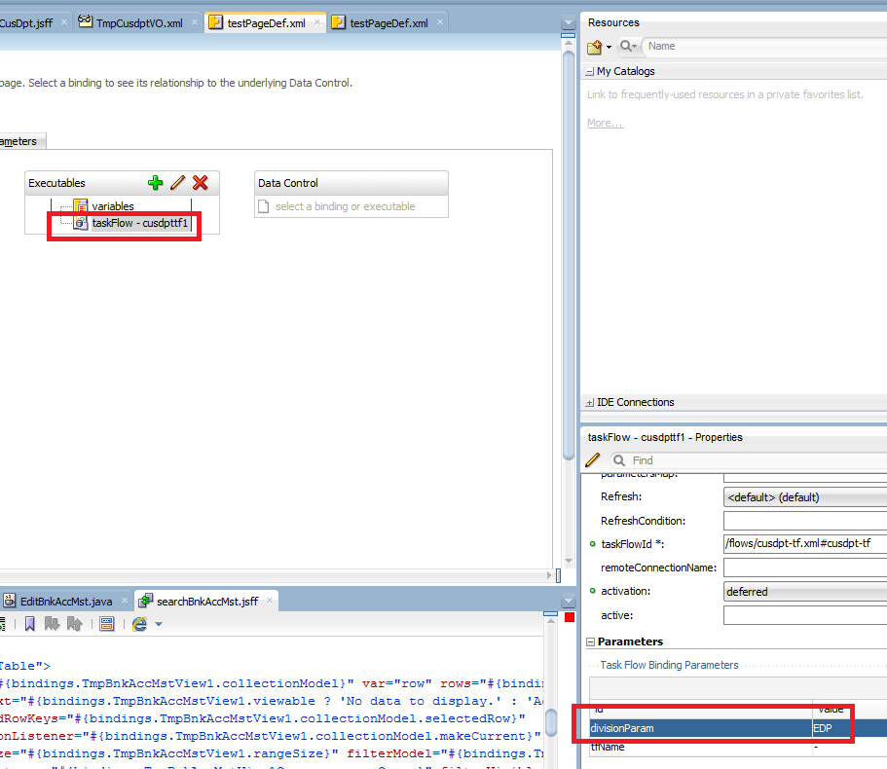

## 4.5 Set Message Bundle correct location

If the message bundle is incorrect place

Select Model -> Project Properties

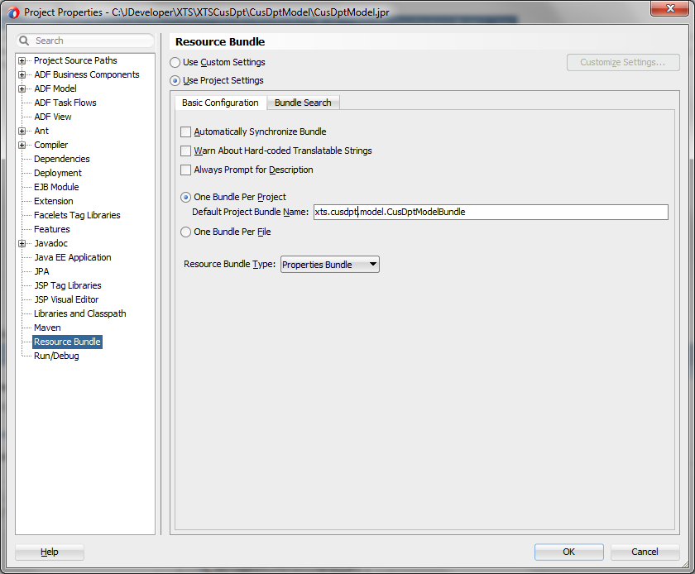

Move TestPage Page Definition to

C:\JDeveloper\XTS\XTSCusDpt\CusDptViewController\src\xts\cusdpt\view\pageDefs

## 4.6 Pass Division Code from Main Menu to your Task Flow

* Create a method in VO Implementation and then expose it in Client Interface
* After this step, try to run test.page to see the result

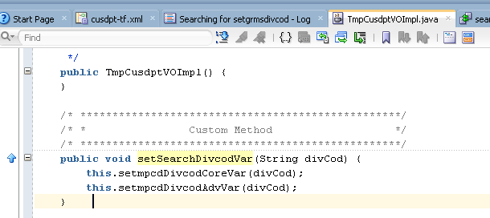

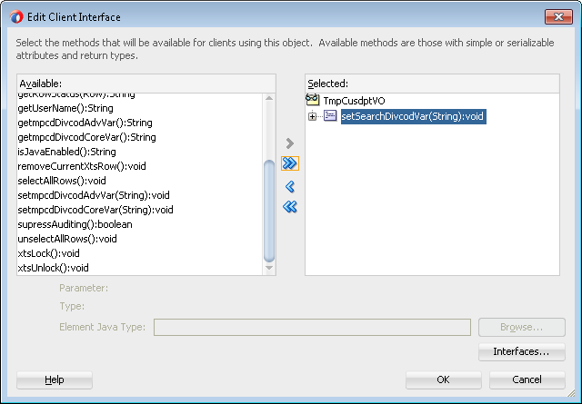

If you cannot see setmpcdDivCodVar method available, please go back to VO, Java Page, and select “Include Bind Variable Accessors” in VOImpl.

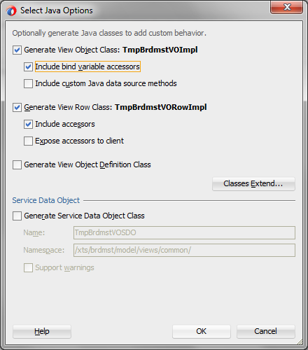

* Refresh the data control to see if you can see the method. If not close the JDeveloper and open again
* Drag it into the Task Flow

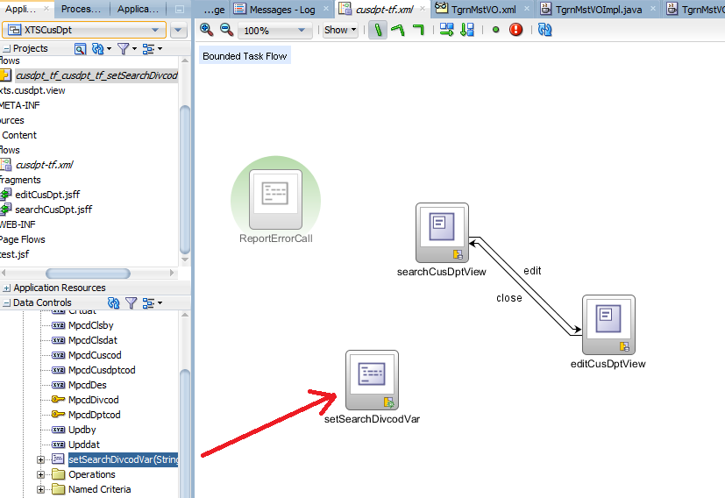

* Add Control Flow “next” and then set Fixed Outcome

|  |  |
| --- | --- |
|  |  |

* Update Page Definition with Division Code as the input Parameter

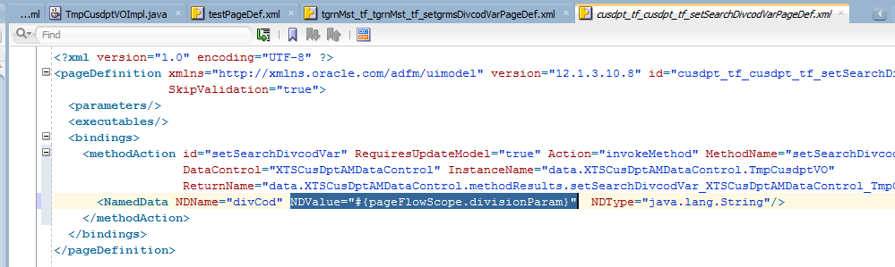

## 4.7 Create Page Fragments for Search Page (Continue from Section 4.2)

### 4.7.1 Change LOV on search screen filter as Input Text of LOV

When you first create the LOV in the VO attribute, you can select input text of LOV.

## 4.8 Create Page Fragments for Edit Page (Continue from Section 4.3)

### 4.8.1 Create method

4.8.1.1 Setup Create Method under VO Implementation

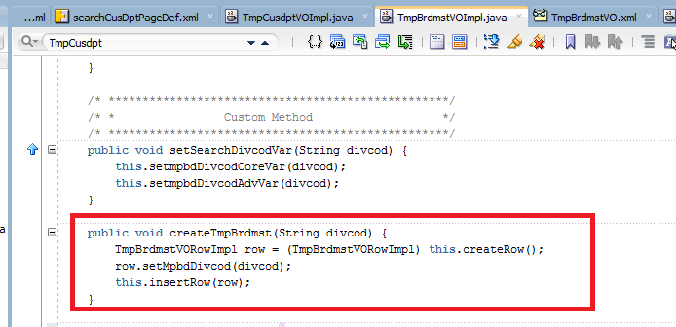

Expose the method into Client Interface

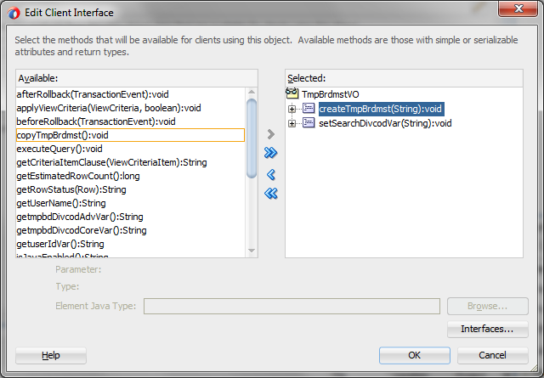

Press add button and choose “methodAction” and point to this method

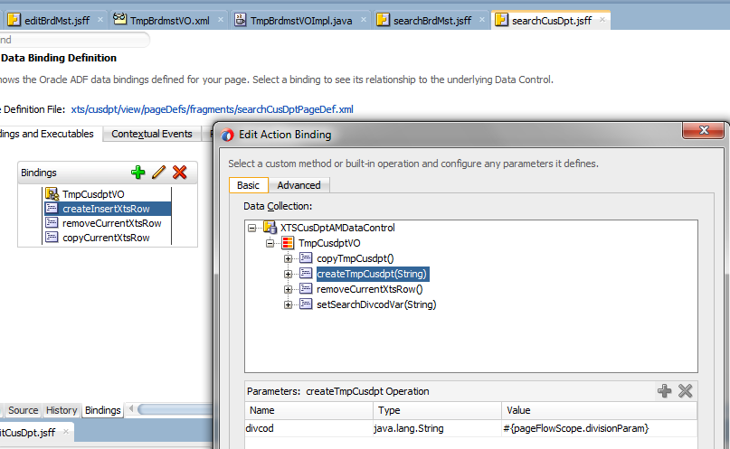

Rename the id to “createInsertXtsRow” / “removeCurrentXtsRow” / “copyCurrentXtsRow”

From 12.2, it seems that ReturnName and InstanceName is not correctly retrieved. You may need to modify it

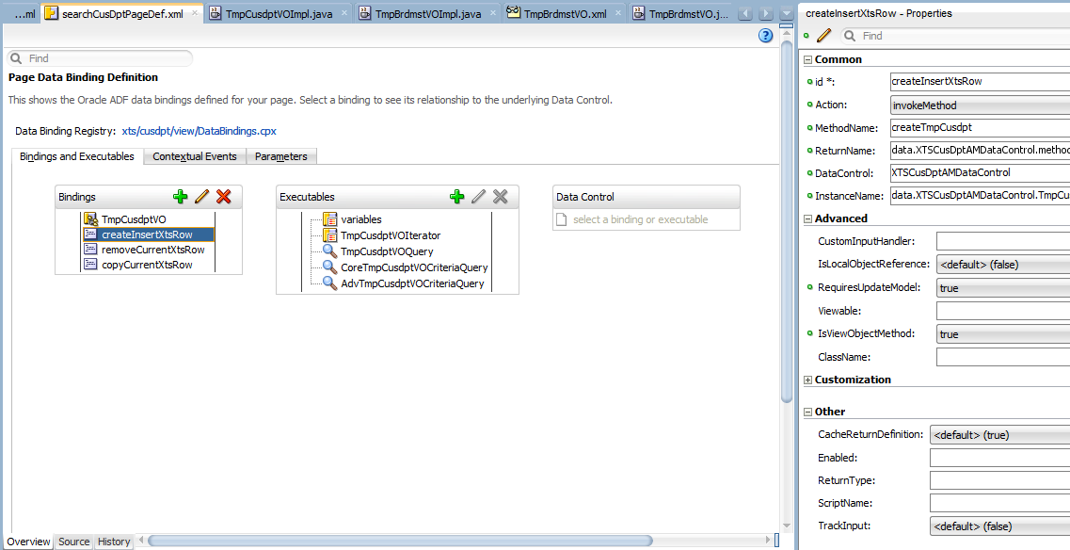

### 4.8.2 Set Enable / Disable of the field

If a field need to enable / disable by ANY logic

* Go to the View Object, select the attribute and under the Custom Properties, add a Non-Translatable Property as disabled and the value as “ “ (leave a space there)  
  
* Open the source mode add the following code

<TransientExpression><![CDATA[adf.object.disabled('GrmsDptcod')]]></TransientExpression>

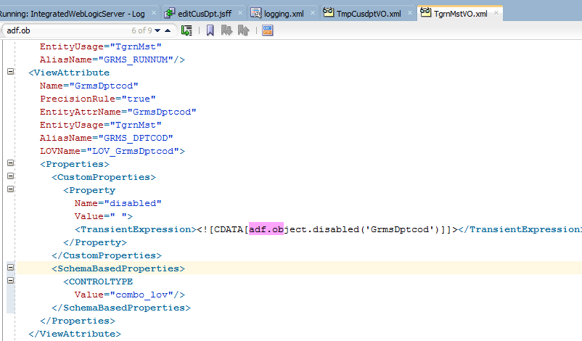

* On the fragment page,
* If it is not under af:table, add property disabled="#{bindings.GrmsDat.hints.disabled}" property
* If it is under af:table, add property disabled="#{row.bindings.GrdlWhCod.hints.disabled}"property
* In case, when disabling should be more complex, then on ViewRowImpl should be overriden calculateDisabled method.

4.8.2.1 Enable / Disable Version 2 (Disable Logic Bean)

* Please refer to SI / Item Maintenance
  1. Under Enquiry / Edit Button + Insert Button, Set up DisabledLogicContainer  and then call dlc.resetData() to reset the bean and then call BC method to update value
  2. From BC method, prepare DisabledLogicContainerModel, and then update disabledControlModel.addData(key, "SHPITM_COUNT", shpitmCount);
  3. From calculatedDisabled, return corresponding true / false for enable or disabled
* You may also refer to XA-127 conversation

### 4.8.3 Add Button for detail table

Always encapsulate the button with an af:toolbar if it is at the top of af:table

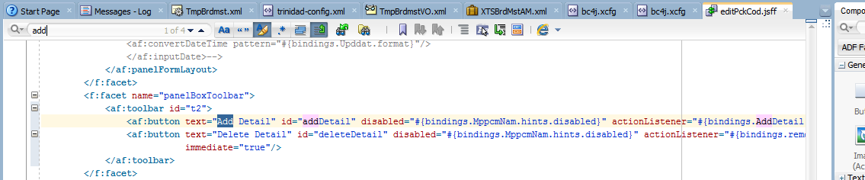

## 4.9 Update ADF Security in XTS Master to include the new task flow

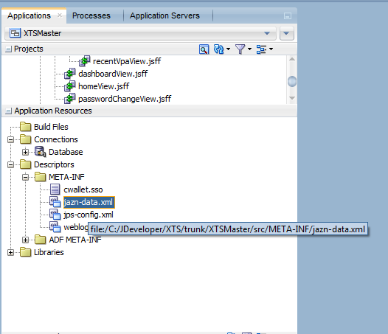

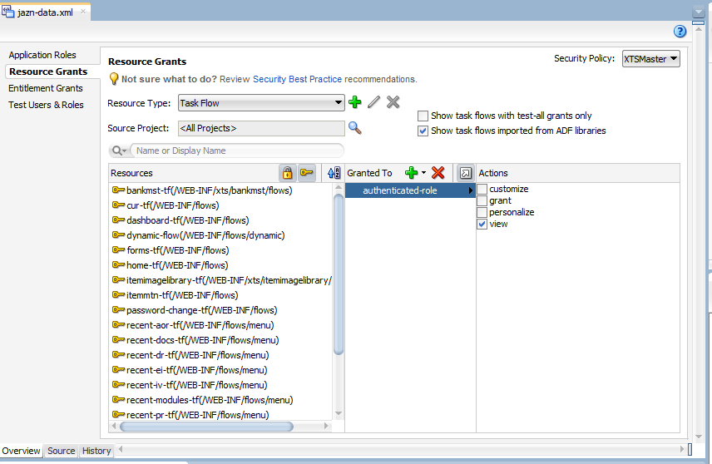

## 4.10 Other General Setting on UI Page

### 4.10.1 Refresh EditToolBar / DetailToolBar after save

When user save a record, ADF will commit the record which will then release the lock within 1 msec.

If any other person issue SELECT FOR UPDATE lock, the lock will be taken by other person.

In that case, the current module should not able to lock the record and should change to enquiry mode.

Please make sure all the UI should be refreshed and changed to disabled only as below.

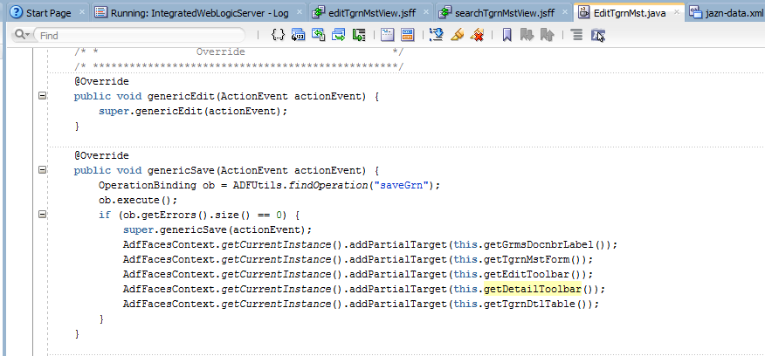

## 4.11 Break a big JSF page into multiple fragment

### 4.11.1 For contents which are always shown (XA-440)

For example, some page in Oracle FORM is very big with lot of fields, such as SO Header Page.

It is not good for JDeveloper to parse a great xml page.

As a result, we will break the page into multiple fragments and add it back to the base page

**Current Flow**

* searchSoMain page will go to editSoHeader page.
* Pressing the tab button, editSoHeader page can go to editSoItem / editSoShipItem / editSoRsv page and vice versa.

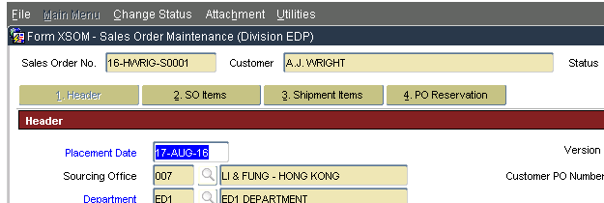

* editSoHeader page got no content inside, apart from reusable toolbar (save, close..), Document no toolbar (Sales Order No / Customer ...), Navigation toolbar (1.Header / 2. SO Item /...)
* The real content for Header Page will be inside editSoHeaderAddAmt / editSoHeaderCusFld / editSoHeaderHdrMisc / editSoHeaderRmk fragment.

**How to add this fragment inside the editHeader page?**

1. Create corresponding “sub” Task Flow, soHeaderAddAmt-tf as below.
2. Add view into the taskflow. Modify the view to the corresponding sub-fragment page,   
   e.g. editSoHeaderAddAmtView into soHeaderAddAmt-tf. Page Name should be without “View” at the end
3. Drag and drop the soHeaderAddAmt taskflow back to editSoHeader page

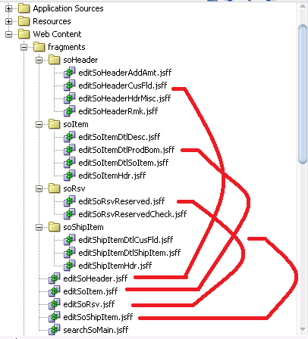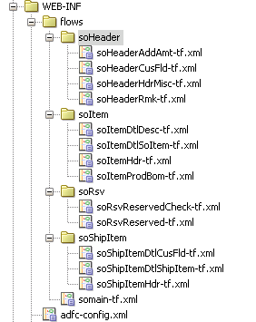

### 4.11.2 For contents which are programmatically shown

Sometimes the section is shown based on the button you pressed, such as from the SO Item Page Detail Section, when “A. Edit SO Item” / “C. Description” button is pressed, it change the bottom section.

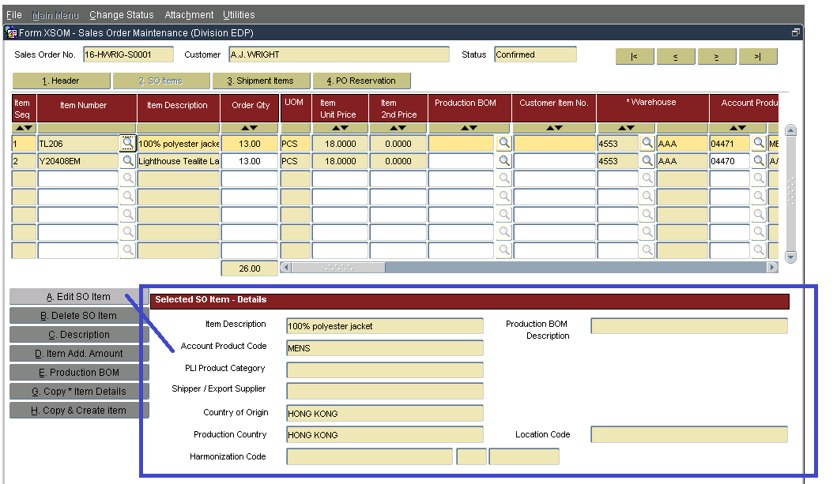

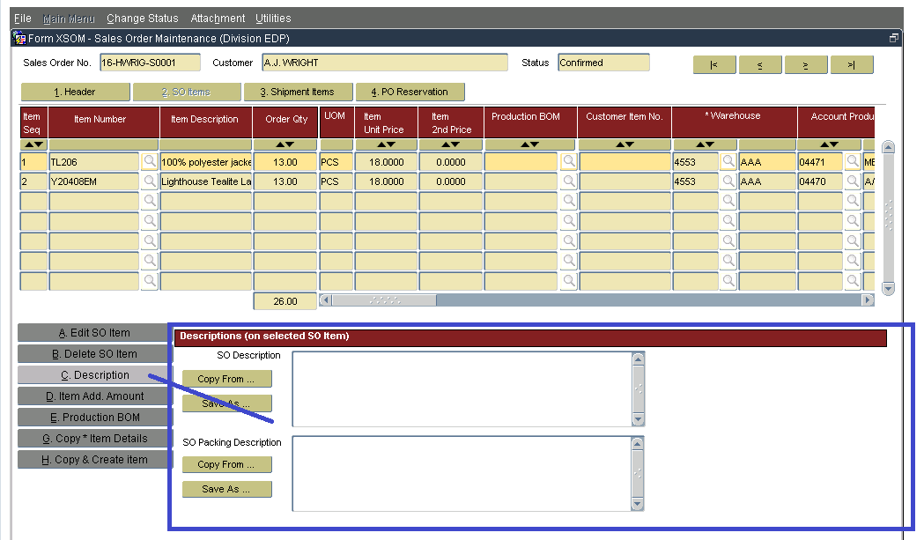

Drag and drop the (default shown) taskflow, e.g. soShipItemDtlShipItem-tf as “Dynamic Region”(One time only) inside <f:facet name=”second”>

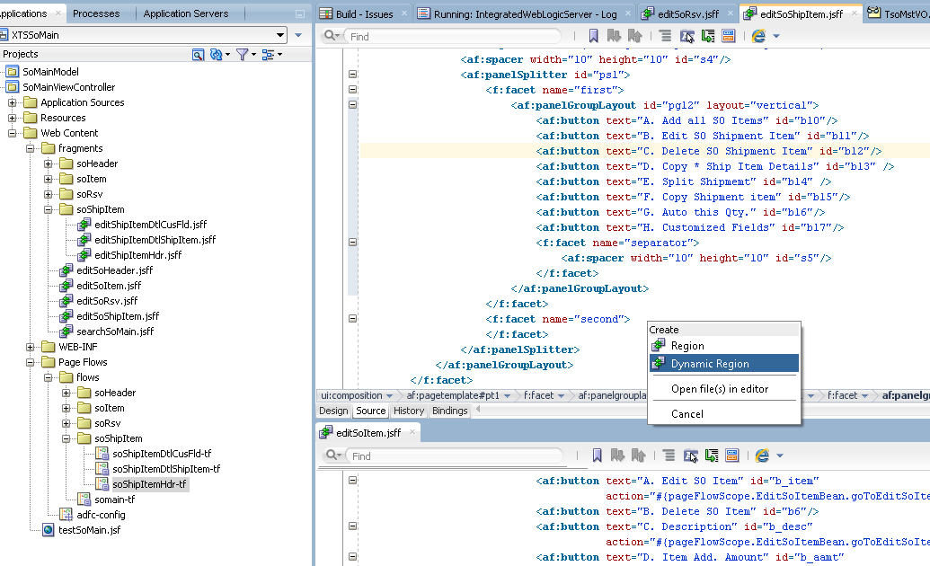

Create a new bean “EditSoShipItemBean” for this page to control the detail tab change

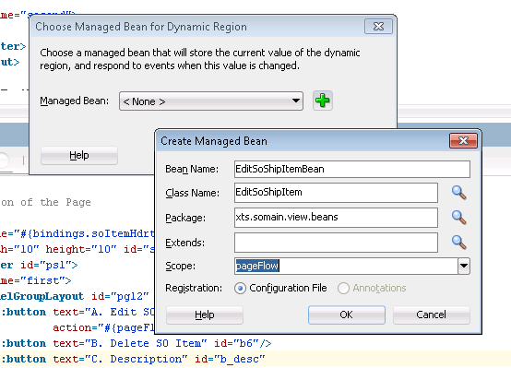

Continue by pressing “OK”

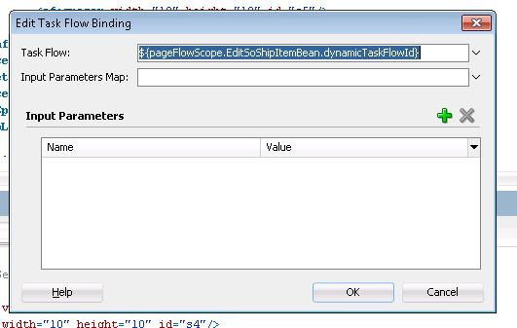

By default, this will create the bean as below and this task flow will be loaded up as the first page in detail section

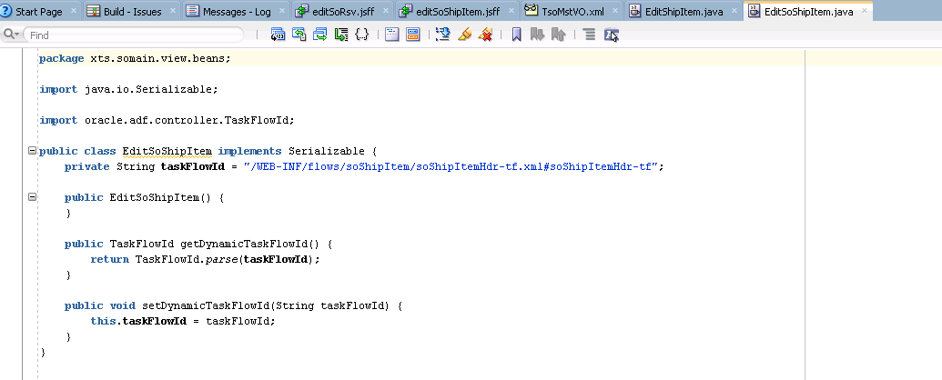

Add 2 methods inside the bean which will be used to navigate between different tab which will triggered by pressing the button

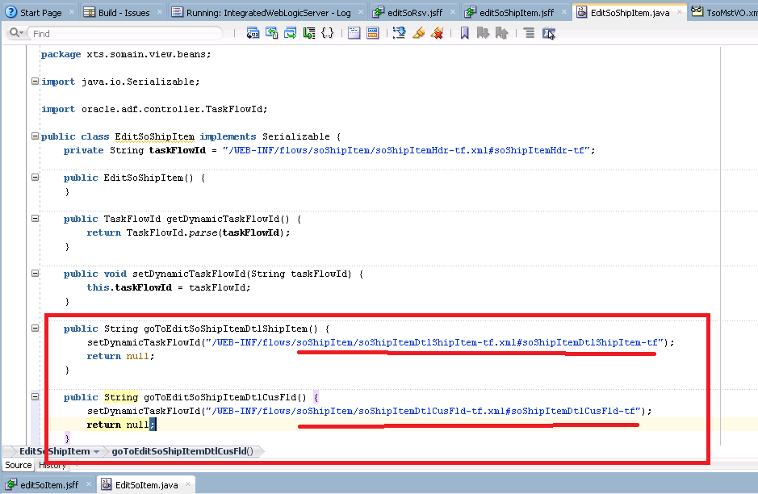

Under the JSFF page, update the id for the button which will trigger a tab page change and then add partial trigger from dynamic region so that it will be refreshed when button is pressed

Then add action on that corresponding button which is based on the Java method created in Java Bean before

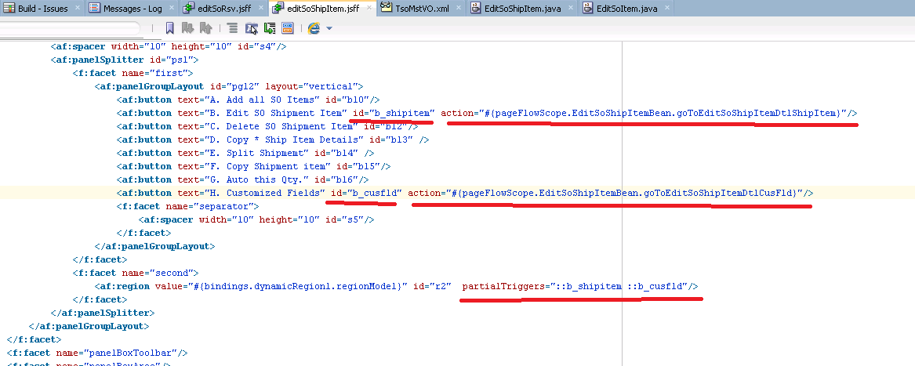

Important Note:

Set Iterator ChangeEventPolicy=ppr to make sure it is refreshed on UI

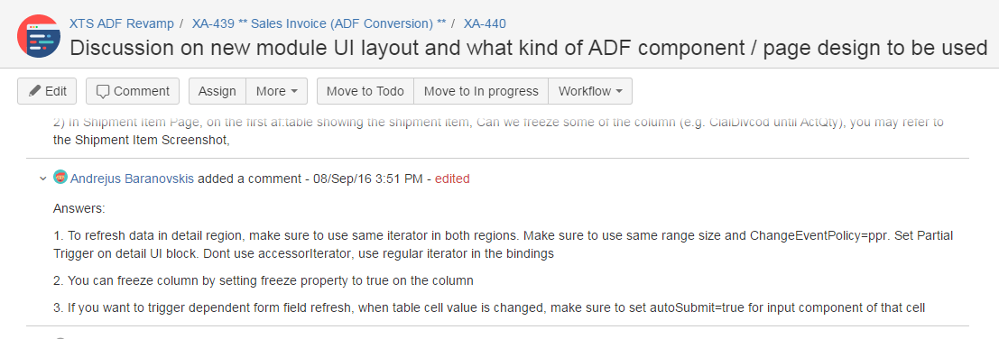

### 4.11.3 To synchronize the record change from master block and detail block (through association)

xxxxxx

### 4.11.4 To synchronize the record change from master block and detail block (through execute query)

xxxxxxx

## 4.12 Responsive UI

## 4.13 Call FORM from ADF

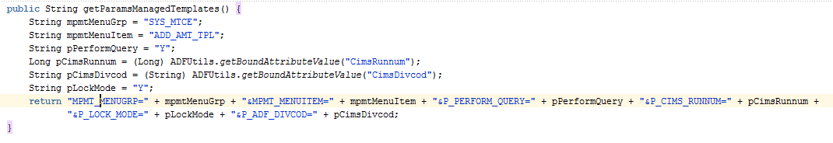

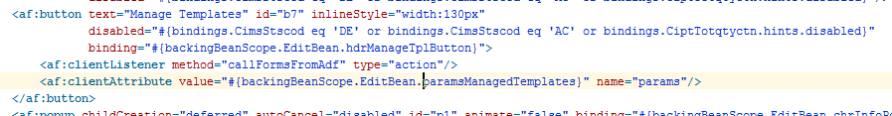

## 4.14 Call ADF from ADF

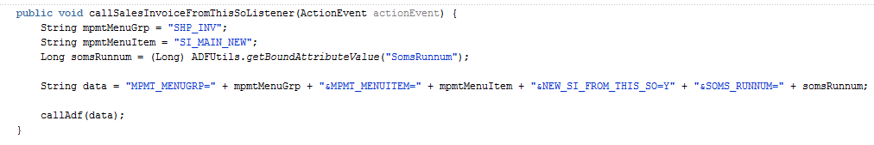

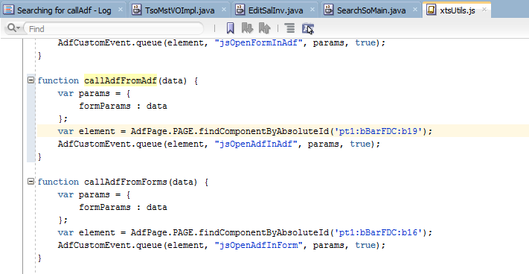

## 4.15 Call Attachment

Please refer to SO / SI for detail. You may also refer to XA-682.

# 5. Special Use Case (Logic)

## 5.1 Check Unique PK when create record

* Use PL/SQL Validator to add Field Level Validation to check if the same PK exists when create new record

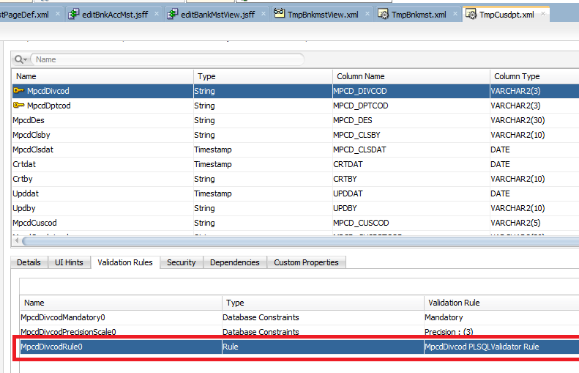

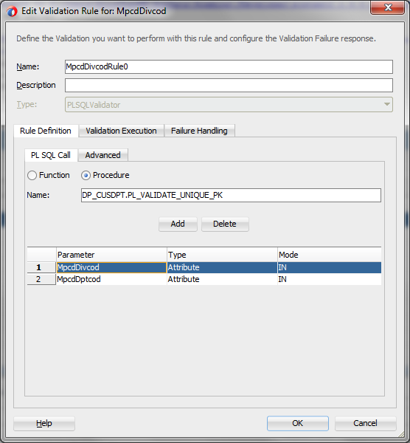

* Disable the PK when edit a record (As a result, the same validation cannot be fired since the value can’t be modified)
  1. disabled="#{!empty bindings.Crtdat.inputValue}"
* (Need to check with Andrejus ) However, it is found that PL/SQL validator won’t execute the same function if the value are the same, but it still able to return the error message based on the 1st load

## 5.2 Prevent PK locking issue

XA-488

Update by Eric

## 5.3 Add Row Sequence in DB to prevent ADF editable primary key issue in af:table

ALTER TRIGGER XTSDBA.TSO_SHI_UPD DISABLE;

ALTER TRIGGER XTSDBA.SOSI_UPD_ANLOG DISABLE;

ALTER TABLE XTSDBA.TSO_SHI ADD (SOSI_ROWSEQ NUMBER GENERATED AS IDENTITY) ;

ALTER TRIGGER XTSDBA.TSO_SHI_UPD ENABLE;

ALTER TRIGGER XTSDBA.SOSI_UPD_ANLOG ENABLE;

Add new sequence in EO / VO, in both EO / VO,

Update SosiRowSeq as PK but mandatory = false, Refresh on Insert = true

Remove PK from Divcod + Runnum + Shiseq + Itmseq

Remove Mandatory from Shiseq + Itmseq

Search “PrimaryKey” / “IsNotNull”

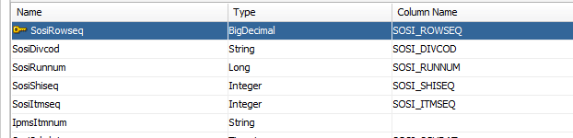

Cannot set immediate = true in af:table, unless it is read-only table.

Because immediate = true will make selectionListener="#{bindings.TsoItmVO.collectionModel.makeCurrent}" NOT WORKING

Also please be careful to update a hidden keyAttribute from xml as well.

Otherwise af:table will not refresh properly

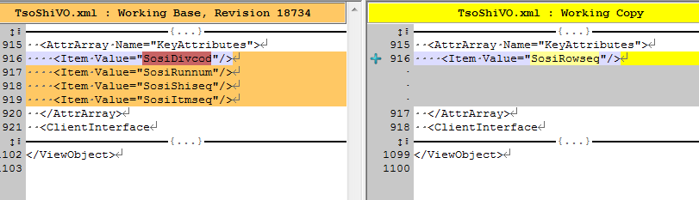

## 5.4 How to handle LONG data type field?

XA-619, XA-689, XA-791

## 5.5 Call PLSQL with ROWTYPE as output parameter

String sql = " declare " +

" v_rec_tci_mst tci_mst%rowtype;" +

" v_rec_tci_prt tci_prt%rowtype;" +

" begin " +

"DP_SI.PL_GET_CUSCOD_DEFAULT(:p1, :p2, :p3, v_rec_tci_mst, v_rec_tci_prt, :p4);" +

" :p5 := v_rec_tci_mst.cims_cndsalcod;" +

" end;";

PLSQLCall dc = new PLSQLCall(sql, null, this.getDBTransaction());

dc.addIn("p1", currentRow.getCimsDivcod());

dc.addIn("p2", currentRow.getCimsDptcod());

dc.addIn("p3", currentRow.getCimsCuscod());

// define access to all return params

dc.addOut("p4", Types.VARCHAR);

dc.addOut("p5", Types.VARCHAR);

dc.executeRaw();

// access return params

System.out.println("v_rec_tci_mst.cims_cndsalcod: " + dc.getObj("p5"));

System.out.println("REMARK: " + dc.getObj("p4"));

// end

## 5.6 How to not run the query when page load (due to AM initialize the VO)

<http://andrejusb.blogspot.hk/2009/08/oracle-adf-tuning-preventing-sql-query.html>

## 5.7 OR Runnum correct solution

Please refer to Sales Order Maintenance / [XA-1057](https://jira.lfapps.net/browse/XA-1057) PI #4 Retrieve incorrect record after changing Actual Delivery Date

6. Special Use Case (UI)

## 6.1 Format Mask

### 6.1.1 Set Field as UPPERCASE

* To save in to DB values in UpperCase - set CASE property on EO attribute with value “UPPER”  
  
* From UI, add contentStyle="text-transform:uppercase;"

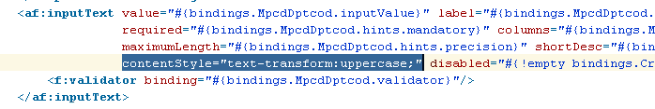

### 6.1.2 Format Mask for Number Field

* Copy XTS Number Formatter definition from 12.1.3 config into 12.2.1.1 formatinfo.xml
* Custom formatter is defined in JDEV system folder o.BC4J\formatinfo.xml file. (C:\Users\[Username]\AppData\Roaming\JDeveloper\system12.2.1.1.42.160607.2047\o.BC4J\ formatinfo.xml)

This is not mandatory, is only for formatter to appear in JDEV UI.

* Then, you would able to define the custom format type in EO.

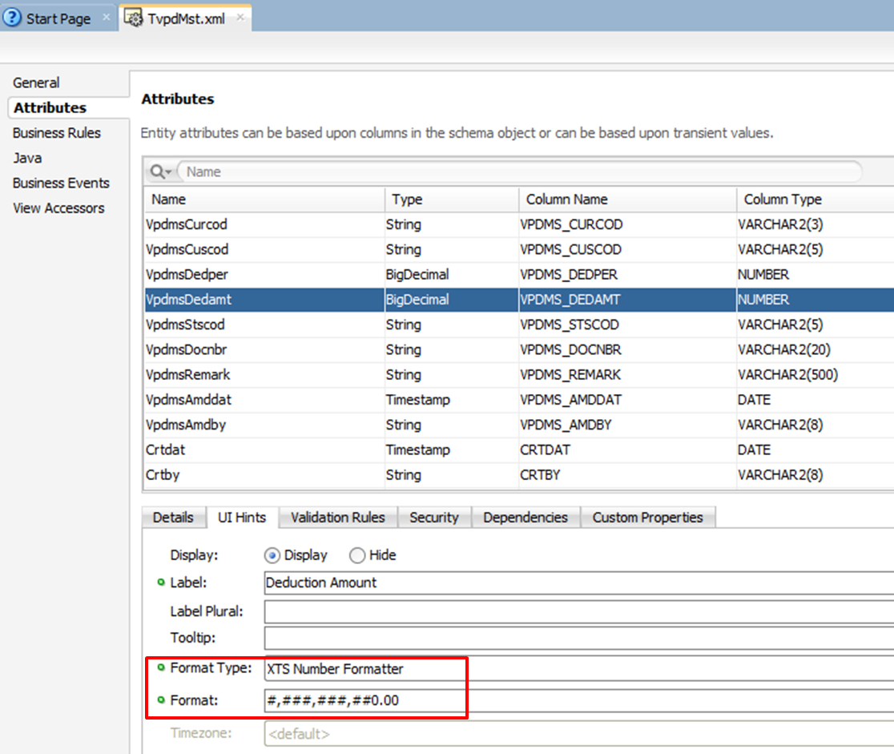

* Comment/remove the <convertnumber> tag in JSFF to prevent rounding issues

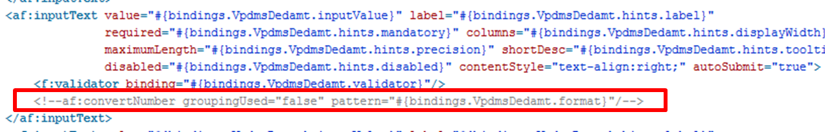

* For more information, please refer to XA-369.
* Using XTSNumberFormatter would cause the text-alignment to be set to left. To set the text-alignment:
  + Use inlineStyle="text-align:right;" for output text
  + Use contentStyle="text-align:right;" for input text

### 6.1.3 Conceal Data

Please refer to XA-794 for detail.

## 6.2 Add Short Cut Key

* Create Hot Keys as <af:clientAttribute/> on button:  
  <af:clientAttribute name="Accelerator" value="Alt+DOM_VK_E"/>

## 6.3 LOV Code and Value Setup

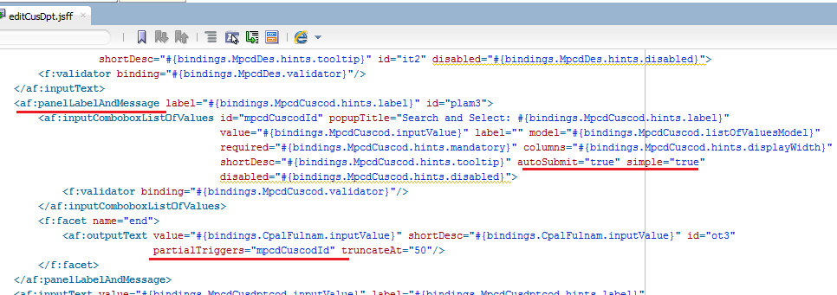

## 6.4 Add Detail / Delete Detail Button

XA-317 (Update by Griffith)

* When implementing a “Delete Detail” button, usually we would not want any validation to run before deleting a row, we would add the property to the button: **immediate=true**.
* After adding “immediate=true” to a button, a resetActionListener must be added to the button to force form refresh. Otherwise, the deleted row might appear again when adding a new detail record. (Please refer to JIRA task XA-256)   
  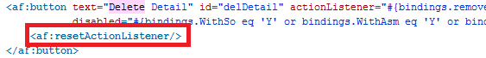
* If you did apply Generic Template for Edit page fragment, put “Add Detail” and “Delete Detail” buttons inside “<af:toolbar>” tag to avoid multiple rows created when adding a new detail record. (Please refer to JIRA task XA-317)

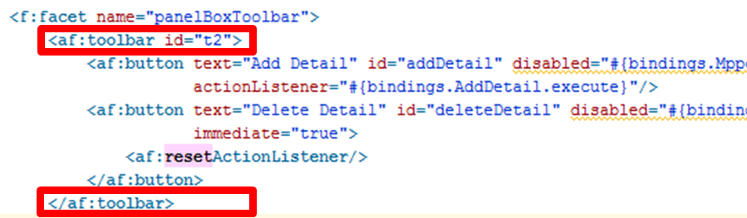

## 6.5 af:table Column Width Setting

1. Select 1 column in your table that does not have constant width for column stretching
2. Set columnStretching=column:[the ID of the column you have chosen]  
     
   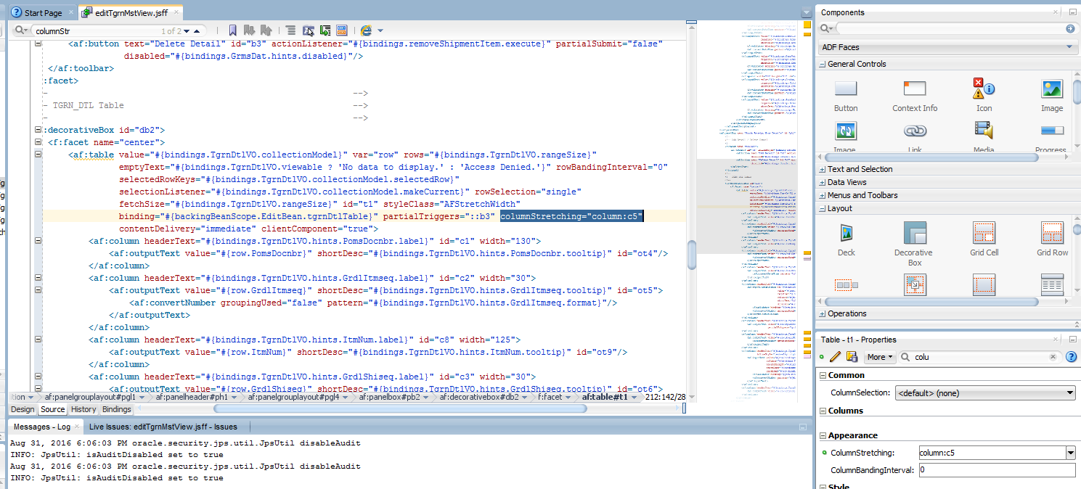
3. For each column, please set the **width** with a specific number, and NOT %, …
4. Do not set minimum width

## 6.6 Revise Instance Name in pageDefinition (12.2 bug?)

Revised From

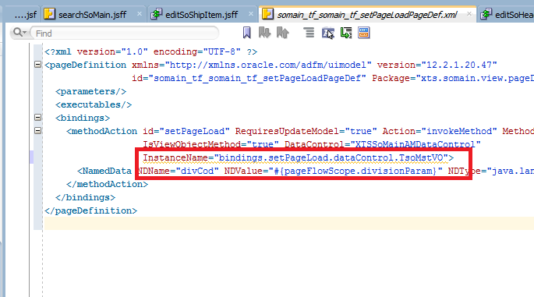

Revised To

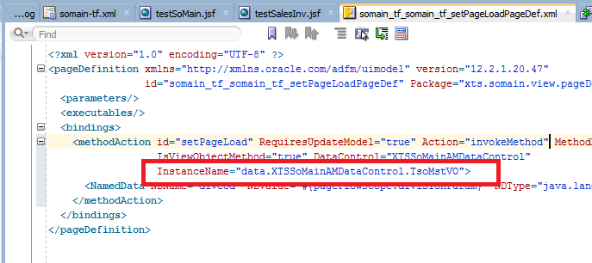

## 6.7 How to create checkbox in UI ?

Update by Kim

## 6.8 Trigger logic after LOV

Update by Eric, XA-587

## 6.9 How to set partial trigger?

Sometimes programtically partial trigger will not work on complex UI.

Therefore you need to refresh the parent component instead of the component you want to refresh.

For detail, you may refer to XA-579

## 6.10 When should you use pageFlowScope bean vs backingBeanScope bean?

Document in XA-605

## 6.11 In Oracle Form, we always check if PRE-TEXT-ITEM <> POST-TEXT-ITEM

You can simply use the setter of the field under ViewRowImpl.

For some input text field, it won’t trigger setter if the value is don’t change

For some LOV, if the LOV return value is different, it will trigger even the

## 6.12 Programatically assign value into VO

Be careful, when you programmatically assign value to a field, if you are using VO.setXXX, it will trigger corresponding LOV call.

????

## 6.13 LOV Switcher

Add 2 LOV into the code field

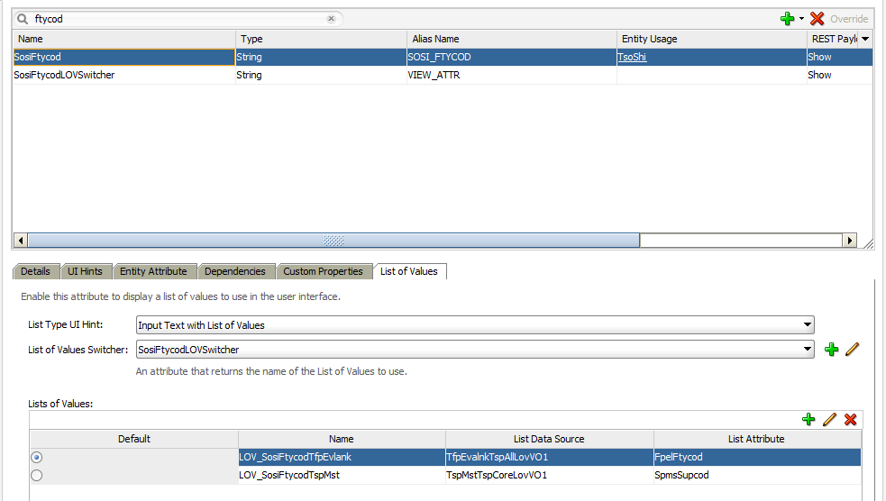

Create Transient Attribute to control the switcher

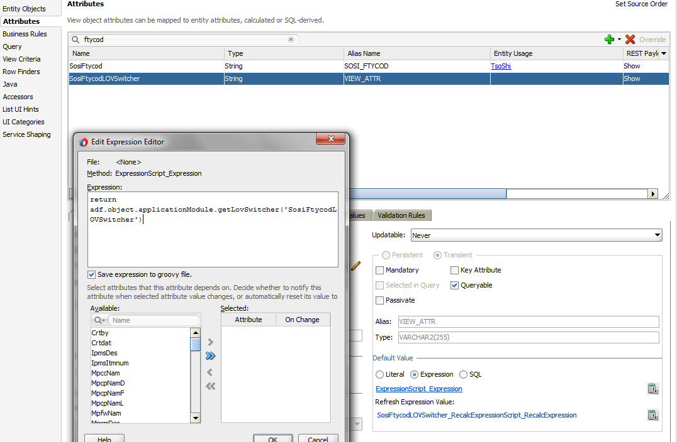

Create method in Application Module

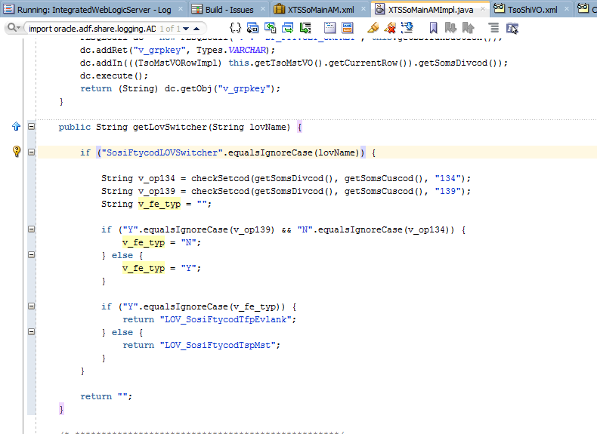

## 6.14 Programmatically called button

JSFUtils.queueActionOnCommandComponmentById("editBtnId");

## 6.15 Reset Pop-Up Dialog

this.executeEmptyRowSet();

## 6.16 Advance Search Standard

1. Only Required fields & Selectively Required fields should be shown in Advance Search except the following:
   1. Search fields with default values (e.g. Invoice Date in SI)
   2. Search fields with LOVs, and LOV is based on the Division Code in Advance Search
   3. If “IN” operator is used, the column runnum will most likely be used. In other words, the column runnum could not be hidden.
2. By Default, all fields in the master table will be available for adding to Advance Search. To hide the fields for Advance Search “Add Fields”, deselect “Queryable” in the column of the respective VO.
3. May refer to XA-641 finding

## 6.17 Suppress LOV to pop-up

XA-708 - not to prompt LOV in (non-LOV) Customized Field if we tab out

## 6.18 LOV inside LOV searching criteria

1. For more information, please refer to Item Maintenance (XA-693)
   1. LOV: Item Maintenance (XTSItemMain) -> TipMstVO -> IpmsPliprd
   2. Related LOV VO: XTSCommonModel -> TmpPrdmstLovVO

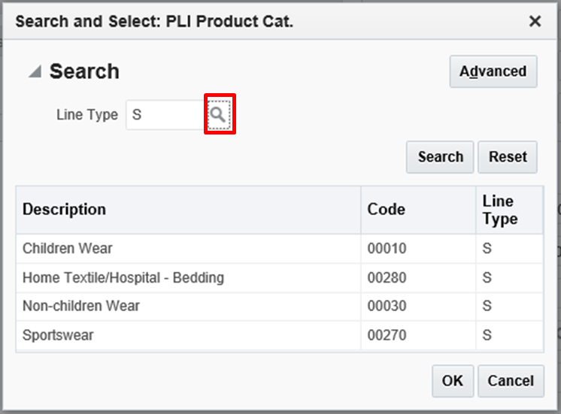

## 6.19 Initialize variable when Form is loaded

1. For more information of how to initialize a variable when Form is loaded and utilize it across the same Form (Similar to WHEN-NEW-FORM-INSTANCE trigger in Oracle FORMS), please refer to
   1. JIRA XA-624
   2. If there is further enquires, may consult Andrejus for the steps to implement this approach.

## 6.20 Conditionally refresh the field based on the result of ADF BC logic

1. For more information of how to force ADF BC model to execute earlier and conditionally refresh the field based on the result of the execution of ADF BC logic, please refer to JIRA XA-808 Scenario 1.

## 6.21 Set Label and Width Proportion

Assuming PanelFormLayout is using fieldWidth="371px" labelWidth="159px", the following is the width I am using:

30% length: 105px   
50% length: 175px   
70% length: 245px   
100% length: 355px

·         Usually there is around 5px space in between 2 fields if using panelLabelAndMessage   
·         If the field is an LOV, I usually take 20px off from the length. For example, for a customer code LOV, I set the width to 105px – 20px = 85px.

## 6.22 Programmatically set Advanced Search Label when Division Code change

Please refer to Mass Update Contract Level Form / talk to Eric

## 6.23 Suppress LOV Prompt Out and Show Error Message

Please refer to Mass Update Contract Level Form / [XA-1243](https://jira.lfapps.net/browse/XA-1243) Suppress LOV Prompt Out and Show Error Message

## 6.24 Checkbox: Combine 2 Request into 1 and Change Checkbox to VO Attribute only

Please refer to Sales Order FORM / [XA-1307](https://jira.lfapps.net/browse/XA-1307)

## 6.25 Bean Usage / How to handle when you move some UI component with binding from one jsf to another jsf ?

Please refer to XA-1352 How to call one binding (HomeBean) at another Bean (RegionController) Bean ?

# 7. Performance Tuning

XA-722 Performance Tuning on SI module

[XA-608](https://jira.lfapps.net/browse/XA-608) Suppress LOV log running in the server

# 8. Database Change Sync to ADF

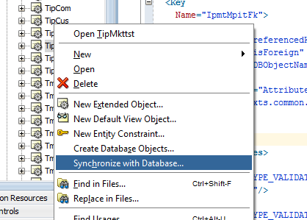

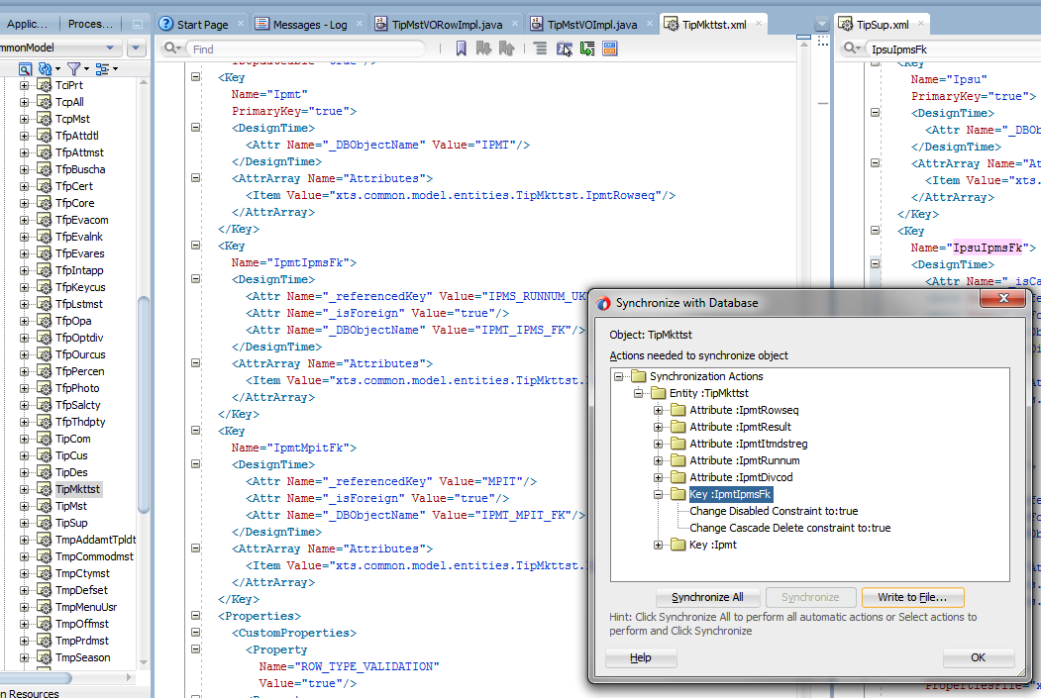

# 9. Server Log

* Go to individual server (infra_server_02, 03, etc..)
* Search the log as below
  + If log exists, update the **Oracle Diagnostic Logging Level (Java Level)**
  + If log NOT exists, under “Specific Loggers” section, copy the log name under “Name” field, update the **Oracle Diagnostic Logging Level (Java Level) and click Apply**

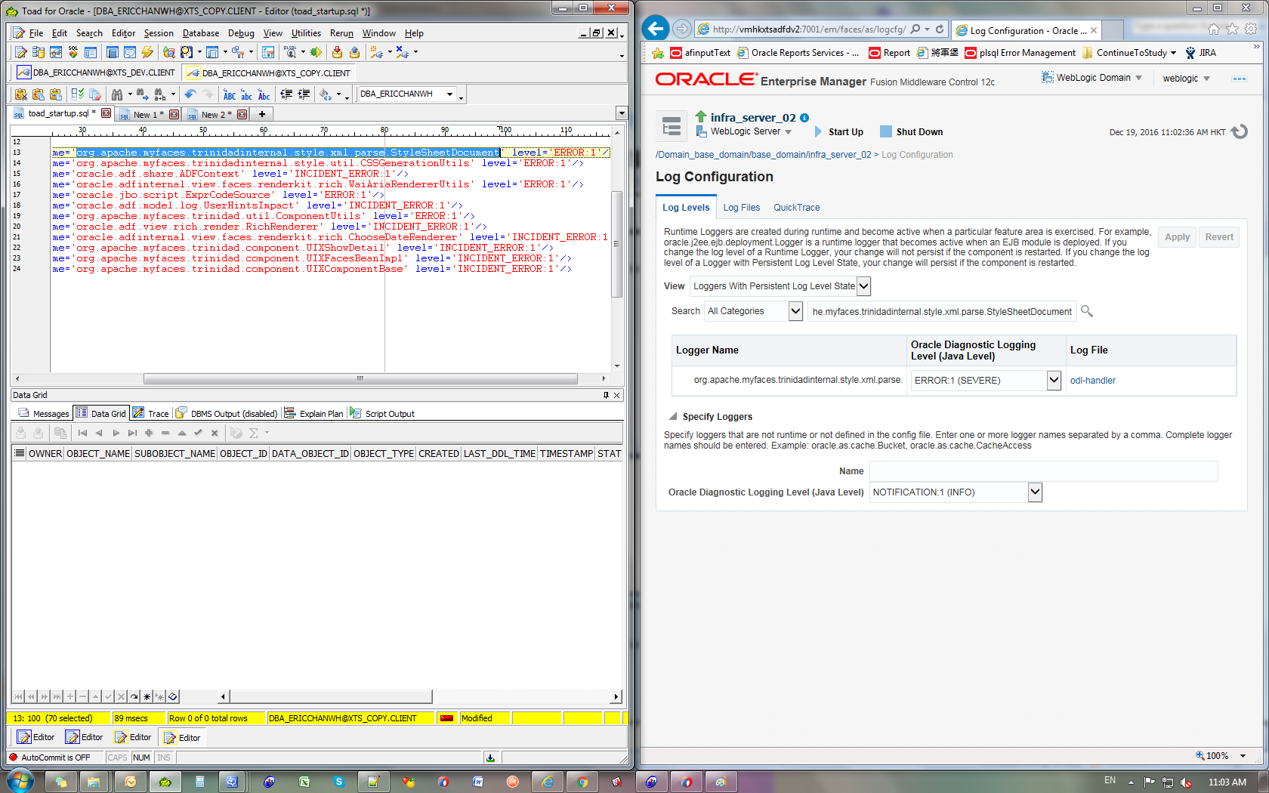

<logger name='org.apache.myfaces.trinidadinternal.style.xml.parse.StyleSheetDocument' level='ERROR:1'/>

<logger name='org.apache.myfaces.trinidadinternal.style.util.CSSGenerationUtils' level='ERROR:1'/>

<logger name='oracle.adf.share.ADFContext' level='INCIDENT_ERROR:1'/>

<logger name='oracle.adfinternal.view.faces.renderkit.rich.WaiAriaRendererUtils' level='ERROR:1'/>

<logger name='oracle.jbo.script.ExprCodeSource' level='ERROR:1'/>

<logger name='oracle.adf.model.log.UserHintsImpact' level='INCIDENT_ERROR:1'/>

<logger name='org.apache.myfaces.trinidad.util.ComponentUtils' level='ERROR:1'/>

<logger name='oracle.adf.view.rich.render.RichRenderer' level='INCIDENT_ERROR:1'/>

<logger name='oracle.adfinternal.view.faces.renderkit.rich.ChooseDateRenderer' level='INCIDENT_ERROR:1'/>

<logger name='org.apache.myfaces.trinidad.component.UIXShowDetail' level='INCIDENT_ERROR:1'/>

<logger name='org.apache.myfaces.trinidad.component.UIXFacesBeanImpl' level='INCIDENT_ERROR:1'/>

<logger name='org.apache.myfaces.trinidad.component.UIXComponentBase' level='INCIDENT_ERROR:1'/>